School: St Mary’s C of E Primary School

Head Teacher – Jenni Matthews

Named personnel with designated responsibility for Safeguarding
Note: All schools should appoint a member of the senior leadership team to coordinate safeguarding arrangements.

Academic Year | Designated Safeguarding Lead | Deputy Designated Safeguarding Lead | Nominated Safeguarding Governor | Chair of Governors
2020/21 | Jenni Matthews | Deborah Haworth  Jess Elliott  Beverley Hall  Amir Lemouchi  Elaine James  Joe Pitchford  Emma Cherry  Leann Valiquette  Christopher Banks  Ellie Ford  Alice Cope  Tania Satari  Khadisha Gerald  Georgie Crawford  Jade Beech  Rebecca Allen  Neisha Bailey  Shinderpal Chatta | Alisha Anderson | Reverend Canon Ade Ademola

Named personnel with designated responsibility regarding allegations against staff

Academic Year | Designated Senior Manager (this would normally be the Head teacher) | Deputy Designated Senior Manager | Chair of Governors | Nominated Governor
2020/21 | Jenni Matthews | Deborah Haworth | Reverend Canon Ade Ademola | Reverend Canon Ade Ademola

Dates the Safeguarding Policy is reviewed and dates of any safeguarding audits

Review Date | Changes made/Details of action plan | Due Date | By Whom
August 2020 | Names changes – training completed by new staff | Autumn 2020 | Governing Body
August 2020 | Review and updating of Safeguarding Policy in light of changes KCSE 2020. | Autumn 2020 | Governing Body
September 2020 | Updating of Safeguarding policy in line with revised KCSiE 2020. | Autumn 2020 | Governing body

Dates of Staff training and details of course title and training provider

Whole school | Designated Safeguarding Lead | Deputy Designated Safeguarding Lead
3rd September 2020  Whole Trust inset – Deborah Haworth | Jenni Matthews  High Speed Training (Online)  May 2019 | Deborah Haworth  High Speed Training (Online)  October 2020
4th September 2019  Internal INSET for all staff |  | Shinderpal Chattha  High Speed Training (Online)  Jan 2020
Joe Pitchford
High Speed Training (Online)
July 2020
Elaine James
High Speed Training (Online)
February 2020
Emma Cherry
High Speed Training (Online)
February 2019
Jenni Matthews
High Speed Training (Online)
May 2019
Neisha Bailey
High Speed Training (Online)
Jan 2019
Beverley Hall
High Speed Training (Online)
October 2020
Amir Lemouchi
High Speed Training (Online)
June 2020
Jess Elliott
High Speed Training (Online)
October 2020
Christopher Banks
High Speed Training (Online)
August 2019
Ellie Ford
High Speed Training (Online)
September 2019
Georgie Crawford
High Speed Training (Online)
September 2019
Jade Beech
High Speed Training (Online)
May 2019
Rebecca Allen
High Speed Training (Online)
November 2019
Leann Valiquette
High Speed Training (Online)
December 2019
Alice Cope
High Speed Training (Online)
November 2020
Tania Satari
High Speed Training (Online)
November 2020
Khadisha Gerald
High Speed Training (Online)
September 2020
INTRODUCTION

This policy has been developed in accordance with the principles established by the Children Acts 1989 and 2004; the Education Act 2002, and in line with government publications. [Section 175 of the Education Act 2002 requires local education authorities and the governors of maintained schools and further education (FE) colleges to make arrangements to ensure that their functions are carried out with a view to safeguarding and promoting the welfare of children.]

Section 157 of the same act and the Education (Independent Schools Standards) (England) Regulations 2003 require proprietors of independent schools (including academies and city technology colleges) to have arrangements to safeguard and promote the welfare of children who are pupils at the school.

This policy is in line with statutory guidance for schools and colleges; Keeping Child Safe in Education (2020), Working Together to Safeguard Children (2019), London Child Protection Procedures (5th Edition), ‘What to do if You are Worried a Child is Being Abused’ 2015 and
WF Early Help and Threshold Criteria for Intervention

The Teacher Standards 2012 state that teachers, including headteachers should safeguard children’s wellbeing and maintain public trust in the teaching profession as part of their professional duties.

- The statutory guidance Keeping Children Safe in Education 2020 is issued under Section 175 of the Education Act 2002, the Education (Independent School Standards) Regulations 2014 and the Education (Non-Maintained Special Schools) (England) Regulations 2015. Schools and colleges must have regard to this guidance when carrying out their duties to safeguard and promote the welfare of children. Unless otherwise stated, ‘school’ in this guidance means all schools, whether maintained, non-maintained or independent, including academies and free schools, alternative provision academies and pupil referral units. ‘School’ includes maintained nursery schools. ‘College’ means further education colleges and sixth form colleges as established under the Further and Higher Education Act 1992. And relates to their responsibilities to children under the age of 18 (but excludes 16-19 academies and free schools, which are required to comply with relevant safeguarding legislation by virtue of their funding agreement)

All staff must read Part One and Annex A of this guidance and staff can find a copy on the staffroom notice board.

Everyone working in or for our school service shares an objective to help keep children and young people safe by contributing to:

- providing a safe environment for children and young people to learn and develop in our school setting, and
- identifying children and young people who are suffering or likely to suffer significant harm, and taking appropriate action with the aim of making sure they are kept safe both at home and in our school setting
- having a designated safeguarding lead available at all times that the school setting is open to discuss concerns; who will provide support to staff members to carry out their safeguarding duties and who will liaise closely with other services such as children’s social care.

SCHOOL COMMITMENT

The Federated Schools of St. Mary’s and St. Saviour’s are committed to safeguarding and promoting the welfare of all of its pupils. Each pupil’s welfare is of paramount importance.

Safeguarding and promoting the welfare of children is everyone’s responsibility. Everyone who comes into contact with children and their families and carers has a role to play in safeguarding children. In order to fulfil this responsibility effectively, all professionals should make sure their approach is child-centred. This means that they should consider, at all times, what is in the best interests of the child.

We recognise that all staff, Directors and Governors have a full and active part to play in protecting our pupils from harm, and that the child’s welfare is our paramount concern.

All staff believe that our school should provide a safe, caring, positive and stimulating environment that promotes the social, physical and moral development of the individual child.

All school and college staff should be prepared to identify children who may benefit from early help. Early help means providing support as soon as a problem emerges at any point in a child’s life, from the foundation years through to the teenage years. In the first instance, staff should discuss early help requirements with the designated safeguarding lead. Staff may be required to support other agencies and professionals in an early help assessment.

We recognise that:

- Some children may be especially vulnerable to abuse
- Children who are abused or neglected may find it difficult to develop a sense of self worth and to view the world in a positive way. Whilst at school, their behaviour may be challenging
- Children can be victims and perpetrators of abuse
- Children who harm others may have been abused themselves
- Allegations can be made against staff, however careful and safe our recruitment practices

This policy will be updated annually and known to everyone working in the school and the governing body. The Governing body takes seriously its responsibility under section 175 of the Education Act 2002 to safeguard and promote the welfare of children; and to work together with other agencies to ensure adequate arrangements within our school to identify, assess, and support those children who are suffering harm.

The school’s safeguarding arrangements are inspected by Ofsted under the judgements for behaviour and safety, and leadership and management.

This policy is available on the school website and is included in the staff induction.

It will also be available to parents on request.

There will be an annual safeguarding audit questionnaire of safeguarding policy and practice (carried out under section 175 of the Education Act 2002).

PROVIDING A SAFE AND SUPPORTIVE ENVIRONMENT

Safer Recruitment and Selection

The school pays full regard to the statutory guidance for schools and colleges; Keeping Child Safe in Education (2020). We ensure that all appropriate measures are applied in relation to everyone who works in the school and who is therefore likely to be perceived by the children as a safe and trustworthy adult. This includes volunteers, supervised volunteers and staff employed by contractors. Safer recruitment practice includes scrutinising applicants, verifying identity and academic or vocational qualifications, obtaining professional references, checking previous employment history and ensuring that a candidate has the health and physical capacity for the job. It also includes undertaking interviews and checks with the Disclosure and Barring Service (DBS).
See Appendix 2 (updated in-line with KCSiE ’20) – Flowchart of Disclosure and Barring Service criminal record checks and barred list checks

Our school endeavours to ensure that we do our utmost to employ safe staff by following the guidance in Keeping Children Safe in Education (2020) together with the LSCB and the school’s Staff Recruitment policy and procedures which can be found on the staffroom notice board.

Safer recruitment means that applicants will:

- complete an application form which includes their employment history and explains any gaps in that history
- provide two referees, including at least one who can comment on the applicant’s suitability to work with children
- provide evidence of identity and qualifications
- if offered employment, be checked in accordance with the Disclosure and Barring Service (DBS) regulations as appropriate to their role. This will include an enhanced DBS check and a barred list check for those engaged in Regulated Activity
- if offered employment, provide evidence of their right to work in the UK
- be interviewed, if shortlisted.

The school will also:
- verify the preferred candidate’s mental and physical fitness to carry out their work responsibilities
- obtain references for all shortlisted candidates, including internal candidates
- carry out additional or alternative checks for applicants who have lived or worked outside the UK
- ensure that applicants for teaching posts are not subject to a prohibition order issued by the Secretary of State.

At least one member of each recruitment panel will have attended safer recruitment training.

All new members of staff will undergo an induction that includes familiarisation with the school’s child protection policy and staff behaviour policy and identification of their child protection training needs.

All staff sign to confirm they have received a copy of the child protection policy and staff behaviour policy/Code of Conduct including acceptable use of technologies, staff/pupil relationships and communications including the use of social media.

All relevant staff (involved in early year’s settings and/or before or after school care for children under eight) are made aware of the disqualification and disqualification by association legislation and their obligations to disclose relevant information to the school All members of staff have signed this disclosure. Section 128 prohibition checks are recorded on the single central record.

The school obtains written confirmation from supply agencies or third party organisations that agency staff or other individuals who may work in the school have been appropriately checked.

Salaried trainee teachers will be checked by the school via an enhanced DBS (with barred list) check. Unsalaried trainee teachers will be checked by the training provider, from whom written confirmation will be obtained that they are suitable to work with children.

The school maintains a single central record of recruitment checks undertaken.

Regulated Activity
Schools are ‘specified places’ which means that the majority of staff and volunteers will be engaged in regulated activity. A fuller explanation of regulated activity can be found in Keeping Children Safe in Education (2020) part three and Annex F.

Volunteers
Volunteers, including governors will undergo checks commensurate with their work in the school and contact with pupils. Under no circumstances will a volunteer who has not been appropriately checked be left unsupervised or be allowed to engage in regulated activity. Governors will be subjected to an Enhanced DBS check within 21 days of being appointed and will also be subject to a section 128 check to ensure they are not barred from involvement in the management of schools.

Supervised volunteers
Volunteers who work only in a supervised capacity and are not in regulated activity will undergo the safe recruitment checks appropriate to their role, in accordance with the school’s risk assessment process and statutory guidance. Risk assessments as to whether to obtain an enhanced DBS certificate for a volunteer who is not engaged in regulated activity will be recorded and will take into account the nature of the work; what the school already knows about the volunteer; references; and whether the role is eligible for an enhanced DBS check.

Pre-School Children and After-School Services
Working Together recognises that facilities for pre-school children and the extended use of school premises play an important part in the lives of large numbers of children. Professionals working within these settings should know how to recognise and respond to the possible abuse or neglect of a child.
All organisations or services including private, voluntary and those that must be registered by Ofsted under the Children Act 1989 should have a written statement based on the procedures laid out in the booklet “What To Do If You’re Worried A Child Is Being Abused” 2015. This statement (see point 17 below) should clearly set out staff responsibilities for reporting suspected child abuse or neglect in accordance with Local Safeguarding Children’s Board procedures (The London procedures in the case of LBWF) and should include telephone numbers for the local police and children’s social services.

Contractors
The school checks the identity of all contractors working on site and requests DBS checks and barred list checks where required by statutory guidance. Contractors who have not undergone checks will not be allowed to work unsupervised or engage in regulated activity.

This school is committed to keeping an up to date single central record detailing a range of checks carried out on our staff.

Lettings
Our lettings policy will ensure the suitability of adults working with children on school sites at any time. Community users organising activities for children are aware of and understand the need for compliance with the school’s child protection guidelines and procedures.

Safe Practice

Our school will comply with the current Guidance for Safer Working Practice for Adults who work with Children and Young People and ensure that information in this guidance regarding conduct, is known to all staff, visitors and volunteers who come into the school.

Safe working practice ensures that pupils are safe and that all staff:
- are responsible for their own actions and behaviour and should avoid any conduct which would lead any reasonable person to question their motivation and intentions;
- work in an open and transparent way;
- work with other colleagues where possible in situations that could be open to question
- discuss and/or take advice from school management over any incident which may give rise for concern;
- record any incidents or decisions made;
- apply the same professional standards regardless of diversity issues;
- be aware of information-sharing and confidentiality policies;
- are aware that breaches of the law and other professional guidelines could result in criminal or disciplinary action being taken against them.

Helping children to keep themselves safe
Children are taught to understand and manage risk through our personal, social, health and economic (PSHE) education and sex and relationships lessons and through all aspects of school life. Our approach is designed to help children to think about risks they may encounter and with the support of staff work out how those risks might be reduced or managed. Discussions about risk are empowering and enabling for all children and promote sensible behaviour rather than fear or anxiety. Children are taught how to conduct themselves and how to behave in a responsible manner. Children are also reminded regularly about e-safety, the risks of sharing content and images online and tackling bullying, including cyber bullying procedures. The school continually promotes an ethos of respect for children, and pupils are encouraged to speak to a member of staff of their choosing about any worries they may have.

All pupils know there is designated safeguarding lead responsible for safeguarding and who this is; that they have a right to speak to this member of staff in confidence. They are reminded that confidentiality cannot be guaranteed, but that they will be listened to, heard and informed of what steps can be taken to protect them from harm and that feedback will be sought, so that their views about actions are known.

Children with special educational needs (SEN) and disabilities can face additional safeguarding challenges. Additional barriers can exist when recognising abuse and neglect in this group of children. These can include:
• assumptions that indicators of possible abuse such as behaviour, mood and injury relate to the child’s disability without further exploration;

• the potential for children with SEN and disabilities being disproportionally impacted by behaviours such as bullying, without outwardly showing any signs; and

• communication barriers and difficulties in overcoming these barriers.

Where there is a safeguarding concern, the governing body, and school leaders will ensure the child’s wishes and feelings are taken into account when determining what action to take and what services to provide. Systems should be in place for children to express their views and give feedback. Ultimately, all systems and processes should operate with the best interests of the child at their heart.

Partnership with Parents

The school shares a purpose with parents to educate and keep children safe from harm and to have their welfare promoted. We are committed to working with parents positively, openly and honestly. We ensure that all parents are treated with respect, dignity and courtesy. We respect parents’ rights to privacy and confidentiality and will not share sensitive information unless we have permission or it is necessary to do so in order to protect a child.

The school will, in most circumstances, endeavour to discuss all concerns with parents about their children. However, there may be exceptional circumstances when the school will discuss concerns with Social Care and/or the Police without parental knowledge (in accordance with the London Child Protection procedures). The school will, of course, always aim to maintain a positive relationship with all parents. The school’s safeguarding policy is available on request.

Partnerships with others

Our school recognises that it is essential to establish positive and effective working relationships with other agencies that are partners of the Waltham Forest Safeguarding Children Board. There is a joint responsibility on all these agencies to share information to ensure the safeguarding of all children.

School Training and Staff Induction

The school’s designated safeguarding lead, deputy designated safeguarding lead and governor with designated responsibility for safeguarding will undertake child protection training for designated safeguarding leads and refresher training at two yearly intervals, with their knowledge and skills refreshed at least annually.

All other school staff, including non teaching staff, will undertake appropriate induction training and safeguarding/child protection training to enable them to carry out their responsibilities for safeguarding effectively, which will be updated regularly, (for example, via email, e-bulletins and staff meetings) as required, but at least annually, to provide them with relevant skills and knowledge to safeguard children effectively.

All staff (including temporary staff, volunteers, supervised volunteers and staff employed by contractors) are provided with the school’s safeguarding policy and informed of the school’s safeguarding arrangements on induction. Induction and training is in line with advice from the LSCB and KCSiE 2020, and will include staff reading this Safeguarding Policy; the Staff Code of Conduct; the Pupil Behaviour Policy; the school’s safeguarding response to children who go missing in education; Part 1 and Annex A of KCSiE 2020; and they will be informed of the identity and role of the DSL and deputies.

We understand that staff should have access to advice on the boundaries of appropriate behaviour. The document “Guidance on Safe Working Practices for the Protection of Children and Staff in Education Settings” provides advice on this and the circumstances which should be avoided in order to limit complaints against staff of abuse of trust and/or allegations of physical or sexual abuse. These matters form part of staff induction and are referred to in the staff handbook.

Support, Advice and Guidance for Staff

Staff will be supported by Jenni Matthews Designated DSL and her deputies.
The deputy DSLs are listed on page 1.

The DSL and Deputy DSLs will have their safeguarding role described in their respective job descriptions.

The DSL will know how to access the on-line London Child Protection Procedures.

If you are not sure whether or not to make a referral to Children’s Social Care, you can contact the Waltham Forest Multi Agency Safeguarding Hub (MASH) Team/Children’s Referral and Advice Team based at Juniper House.

See Appendix 3 – Key Contacts for Child Protection Issues in Waltham Forest

Related School Policies

Safeguarding covers more than the contribution made to child protection in relation to individual children. It also encompasses issues such as pupil health and safety, bullying and a range of other issues, for example, arrangements for meeting the medical needs of children providing first aid, school security, drugs and substance misuse, positive behaviour etc. There may also be other safeguarding issues that are specific to the local area or population.

Use of Reasonable Force
‘Reasonable’ force means using no more force than is needed in circumstances where it is appropriate to physically control or restrain a child; this could range from guiding a child to safety, to more extreme circumstances such as breaking up a fight or where a child needs to be prevented from being violent. Staff who are likely to need to use specialist positive handling techniques should be appropriately trained. By planning positive and proactive behaviour support, for instance drawing up individual behaviour plans for more vulnerable children (including children with SEN, disabilities or medical conditions) and agreeing them with parents and carers, we can reduce the occurrence of challenging behaviour and the need to use reasonable force.

We understand that positive handling of a nature that causes injury or distress to a child may be considered under child protection or disciplinary procedures.

E-Safety

As schools and colleges increasingly work online, it is essential that children are safeguarded from potentially harmful and inappropriate online material. As such, governing bodies and school staff should ensure appropriate filters and appropriate monitoring systems are in place. However, they should be careful that “over blocking” does not lead to unreasonable restrictions as to what children can be taught with regards to online teaching and safeguarding.

The school recognises that its pupils will use mobile phones and computers at some time. They are a source of fun, entertainment, communication and education. Our pupils increasingly use electronic equipment on a daily basis to access the internet and share content and images via social networking sites such as Facebook, Twitter, MSN, tumblr, Snapchat, TikToc and Instagram.

Unfortunately, some adults and young people will use these technologies to harm children. The harm might range from sending hurtful or abusive texts and emails, to grooming and enticing children to engage in sexually harmful conversations, webcam photography or face-to-face meetings. Pupils may also be distressed or harmed by accessing inappropriate websites that promote unhealthy lifestyles, extremist behaviour and criminal activity.

The school’s e-safety policy (this can be found on the federated drive under policies and up on the staffroom notice board) explains how we try to keep pupils safe in school and protect and educate pupils in the safe use of technology. Cyberbullying and sexting by pupils will be treated as seriously as any other type of bullying and will be managed through our anti-bullying procedures. Serious incidents may be managed in line with our sexual exploitation policy or child protection procedures.

Many pupils own or have access to hand held devices and parents are encouraged to consider measures to keep their children safe when using the internet and social media at home and in the community. Mobile 3G/4G/5G technology is not permitted to be used on the school’s premises by older pupils who have permission to store their phone in the office in school hours. Any incidents of abuse using 3G/4G/5G technology on school premises will be subject to the school’s anti-bullying and/or safeguarding procedures depending on the nature of the abuse.

All staff receive e-safety training and the school’s e-safety coordinator is: Bonnie Buckley

Chatrooms and social networking sites are the most obvious sources of inappropriate and harmful behaviour, which pupils are not allowed to access in school. Some pupils will undoubtedly ‘chat’ on mobiles or social networking sites at home and parents are encouraged to consider measures to keep their children safe when using social media.

The school has an e-safety policy that is known to all staff and pupils.

Internet Websites
- Access will be granted for all
- Access must be age appropriate
- Access must be for educational purposes
- Internet access designed for pupil use
- Access will be filtered and monitored
- Pupils informed of Internet monitoring
- Rules will be posted near all computers
- Pupils sign an internet acceptable use policy annually.

Parents
- Use of newsletters, school brochure and school website to draw attention
- Issues to be handled sensitively
- A partnership approach potentially including demos, practical sessions and suggestions for safe Internet use at home.
- To be informed about pupil use/access
- Sign appropriate use policy annually.

Photography and Images
The vast majority of people who take or view photographs or videos of children do so for entirely innocent, understandable and acceptable reasons. Sadly, some people abuse children through taking or using images, so we must ensure that we have some safeguards in place.

To protect pupils we will:
- seek their consent for photographs to be taken or published (for e.g. on our website or in newspapers or publications)
- seek specific parental consent for each of the different forms of publishing of photos in accordance with GDPR regulations
- use only the pupil’s first name with an image
- ensure pupils are appropriately dressed
- encourage pupils to tell us if they are worried about any photographs that are taken of them

Acceptable Use of Mobile Phones & Cameras, especially in EYFS
It is our intention to provide an environment in which children, parents and staff are safe from images being recorded and inappropriately used.
Mobile Phones
The School allows staff to bring in personal mobile telephones and devices for their own use.
- Users bringing personal devices into school must ensure there is no inappropriate or illegal content on the device.
- All staff must ensure that their mobile telephones/devices are left inside their bag throughout contact time with children. Mobile phone calls may only be taken at staff breaks or in staff members’ own time.
- If staff have a personal emergency they are free to use the school phone or make a personal call from their mobile (in an area where no children are present or in the office).
- If any staff member has a family emergency or similar and required to keep their mobile phone to hand, prior permission must be sought from the Manager or Leader.
- Staff (will need to) ensure that the School Business Manager has up to date contact information and that staff make their families, children’s schools etc, aware of emergency work telephone numbers. This is the responsibility of the individual staff member.
- All parent helpers/students will be requested to place their bag containing their phone in the cupboard/locker/office and asked to take or receive any calls in the office area.
- It is the responsibility of all members of staff to be vigilant and report any concerns to the Class Teacher or Member of Senior Leadership.
- Concerns will be taken seriously, logged and investigated appropriately.
Cameras
Photographs are taken for the purpose of recording a child or group of children participating in activities or celebrating their achievements is an effective form or recording their progression in the Early Years Foundation Stage and across the school. They may also be used on our website and/or by the local press with permission from the parents.
- However, it is essential that photographs are taken and stored appropriately to safeguard the children in our care.
- Only the designated school cameras are to be used to take any photo within the setting or on outings.
- Images taken on this camera must be deemed suitable without putting the child/children in any compromising positions that could cause embarrassment or distress.
- All staff are responsible for the location of the camera; this should be placed within the filing cabinet in the classroom at the end of the day.
- Images taken and stored on the camera must be downloaded as soon as possible, ideally once a week.
- Images must only be down-loaded by the nominated senior member of staff. If the technology is available images should be downloaded on-site. Should this facility not be available these may be downloaded off-site and erased from the personal computer as soon as the images have successfully been printed.
- For children within the EYFS settings, photographs should then be distributed to members of staff (keyworkers) to record in children’s learning journals.
- Under no circumstances must cameras of any kind be taken into the bathrooms without prior consultation with the Senior Management.
- If photographs need to be taken in a bathroom, i.e. photographs of the children washing their hands, then the Senior Management must be asked first and staff be supervised whilst carrying out this kind of activity. At all times the camera must be placed in a prominent place where it can be seen.
- Failure to adhere to the contents of this policy will lead to disciplinary procedures being followed.

Children Missing from School and Education
Attendance, absence and exclusions are closely monitored. A child going missing from education is a potential indicator of abuse and neglect, including sexual abuse and sexual exploitation. The DSL will monitor unauthorised absence and take appropriate action including notifying the local authority, particularly where children go missing on repeated occasions and/or are missing for periods during the school day. Staff must be alert to signs of children at risk of travelling to conflict zones, female genital mutilation and forced marriage.

The school follows the Safeguarding Children Practice Guidance; Children Missing from School from the London Child Protection Procedures and will refer all cases of concern to the Education Welfare Officer (EWO) and Children’s Social Care.

Where parents inform our school that they wish to 'home educate' their child, our school will inform Waltham Forest BACME, who will implement the “Elective Home Education’ procedure. In Waltham Forest, the Behaviour, Attendance and Children Missing Education service (BACME) is responsible for the delivery of CME (Children Missing from Education) duties defined by the Education Act Amendments.

Extended School and Off-Site Arrangements
Where extended school activities are provided by and managed by the school, our own safeguarding policy and procedures apply. If other organisations provide services or activities on our site we will check that they have appropriate procedures in place, including safer recruitment procedures.

When our pupils attend off-site activities, including day and residential visits and work related activities, we will check that effective safeguarding arrangements are in place.

When one of our pupils is placed with an alternative provision provider, we continue to be responsible for the safeguarding of the pupil and will ensure that written confirmation is received from the provider that appropriate safeguarding checks have been made on all staff at the establishment.

Confidentiality
The school will operate with regard to Information Sharing: Guidance for practitioners and managers (2015), and have a clear and explicit confidentiality policy.

“Where there is a concern that the child may be suffering or is at risk of suffering significant harm, the child’s safety and welfare must be the overriding consideration.”

The school policy should indicate:

- When information must be shared with police and social care where the child/young person is / may be at risk of significant harm
- When the pupil’s and/or parent’s confidentiality must not be breached
- That information is shared on a need to know basis

Pupil Information
The School’s record-keeping policy for child welfare and child protection is consistent with DfE guidance, which is known to all staff.

In order to keep children safe and provide appropriate care for them, our school requires accurate and up to date information regarding:

- names and contact details of persons with whom the child normally lives
- names and contact details of all persons with parental responsibility (if different from above)
- emergency contact details – where reasonably possible, more than one emergency contact number will be held
- details of any persons authorised to collect the child from school (if different from above)
- any relevant court orders in place including those, which affect any person’s access to the child (e.g. Residence Order, Contact Order, Care Order, Injunctions etc.)
- if the child is or has been subject to a child protection or care plan
- name and contact detail of G.P.
- any other factors which may impact on the safety and welfare of the child

The school will collate, store and agree access to this information.

All child protection documents will be retained in a ‘Child Protection’ file, separate from the child’s main file. The main file will clearly show an alert that a child protection file exists and the location of this. This child protection file will be locked away and only accessible to the head teacher and the designated safeguarding lead. These records will be copied and transferred to any school or setting the child moves to, clearly marked ‘Child Protection, Confidential, for attention of Designated Person Child Protection. Original copies will be retained according to school policy on retention of records. This year, all child protection referrals will be reported and uploaded on CPOMS which is child protection software for schools. Historic cases will continue to be stored and accessed as described above whilst new cases will be logged on CPOMS.

The Head Teacher or Designated Members of Staff will disclose personal information about a pupil to other members of staff on a need to know basis only. However, all staff must be aware that they have a professional responsibility to share information with other agencies in order to safeguard children.

Checking toilets procedures
If you need to check a child or children in the toilet, please follow these steps:
- Knock on the door and ask if the child is inside. Do not enter.
- If affirmative, wait for the child to come outside.
- If the child is not coming out, ask if there is anything you can do to support.
- If the child does not respond, ask someone to watch the door and call a member of SLT.
- When there are two staff members available, you can enter the toilet. Let the child know you are doing so.
- If the SLT’s immediate concern is that the child’s safety is at risk, then look over the cubicle door to check the child.
- If you are not concerned for the child’s safety, coach the child and persuade him/ her to come out.
- If the child refuses to do so for over ten minutes, use a tool or key to open the door.
- Ensure the child is safe and do not let any other children in.
- Escort the child safely out of the toilet and following advice from the Senior Safeguarding Lead/ Headteacher contact the parent or carer immediately
- Complete the usual safeguarding procedures.

Roles and Responsibilities

Our Governing Body will ensure that:
- the school has a safeguarding policy and procedures in place that are in accordance with local authority guidance and locally agreed inter-agency procedures, and the policy is made available to parents on request;
- the school operates safer recruitment procedures and makes sure that all appropriate checks are carried out on staff and volunteers who work with children;
- the school follows the London Child Protection procedures for dealing with allegations of abuse against staff and volunteers
- a senior member of the school’s leadership team is designated to take lead responsibility for safeguarding (and deputy);
- they have a named governor lead for safeguarding;
- staff undertake appropriate safeguarding/child protection training, at regular intervals;
- they remedy, without delay, any deficiencies or weaknesses regarding safeguarding arrangements;
- a governor is nominated to be responsible for liaising with the LA and /or partner agencies in the event of allegations of abuse being made against the head teacher;
- where services or activities are provided on the school premises by another body, the body concerned has appropriate policies and procedures in place in regard to safeguarding children and liaises with the school on these matters where appropriate;
- they review their policies and procedures annually and provide information to the LA about them and about how the above duties have been discharged

Our Headteacher will ensure that:
- The policies and procedures adopted by the Governing Body or Proprietor are fully implemented, and followed by all staff;
- Sufficient resources and time are allocated to enable the designated person and the deputy to carry out their roles effectively including the assessment of pupils and attendance of strategy discussions and other necessary meetings; for e.g. child protection conferences and core group meetings;
- All staff and volunteers feel able to raise concerns about poor or unsafe practice in regard to children, and such concerns are addressed sensitively and effectively in a timely manner in accordance with the agreed Whistle Blowing Policy (Appendix 4);
- All pupils are provided with opportunities throughout the curriculum to learn about safeguarding, including keeping themselves online;
- They have completed the on-line Safer Recruitment training;
- The procedure for managing allegations against staff is known to staff and displayed in staff rooms;
- Operate the procedure for managing allegations effectively and refer relevant concerns to the Local Authority Designated Officer (LADO);
- Anyone who has harmed or may pose a risk to a child is referred to the DBS;
- A deputy senior manager is appointed to deal with allegations against staff in the absence of the head teacher.
- The name of the Designated Safeguarding Lead is displayed clearly throughout the school.
- All CP records are kept confidentially and securely and are separate from pupil records.
- An indication that there is a confidential Child Protection file, (kept in a separate and secure place), is marked on the pupil’s records.

Senior Member of Staff with Designated Responsibility for Child Protection will:

- Refer cases of suspected abuse or allegations to children’s social care and maintain a record of all referrals;
- Act as a source of support, advice and expertise within the educational establishment and have access to the online London Child Protection Procedures;
- Liaise with the headteacher to inform him/her of any issues and ongoing investigations and ensure there is always cover for this role;
- Recognise how to identify signs of abuse and know when it is appropriate to make a referral;
- Have knowledge of the escalation policy, the Local Authority Designated Officer (LADO) role, conduct of a child protection case conference and be able to attend and contribute to these;
- Ensure that all staff have access to and understand the school’s safeguarding policy;
- Ensure that all staff have induction training;
- Keep detailed, accurate and secure written records;
- Obtain access to resources and attend any relevant or refresher training courses every two years.
- Ensure the safeguarding policy is updated and reviewed annually and work with the Governing Body regarding this;
- Ensure parents are made aware of the safeguarding policy which alerts them to the fact that referrals may be made and the role of the establishment in this to avoid conflict later;
- Where a child leaves the establishment, ensure the child protection file is copied for the new establishment ASAP and transferred to the new school separately from the main pupil file, as well as ensure the pupil’s social worker is informed. The DSL should also consider sharing information in advance of transferring the CP file.
- Ensure that any absence of one/two days, without satisfactory explanation, of a pupil subject to a Child Protection Plan is referred to the School’s Education Welfare Officer and/or the Child’s Social Worker without delay.
- Provide an annual report for the Governing Body, detailing any changes to the policy and procedures; training undertaken by the Designated Members of Staff, and by all staff and Governors; relevant curricular issues, number and type of incidents/cases, and number of children referred to social services and who are subject to a Child Protection Plan.
- Ensure that the Head Teacher, who is responsible for Looked After Children (LAC), ensures that an up to date list of children is regularly reviewed and updated.

All staff and volunteers will:

Fully comply with the school’s policies and procedures, attend appropriate training and inform the designated safeguarding lead of any concerns.

IDENTIFYING CHILDREN AND YOUNG PEOPLE WHO MAY BE
SUFFERING SIGNIFICANT HARM

Teachers and other adults in school are well placed to observe any physical, emotional or behavioral signs, which indicate that a child may be suffering significant harm. The relationships between staff, pupils, parents and the public which foster respect, confidence and trust can lead to disclosures of abuse, and/or school staff being alerted to concerns.

As in the Children Acts 1989 and 2004, a child is anyone who has not yet reached his/her 18th birthday.

Harm means ill-treatment or impairment of health and development, including, for example, impairment suffered from seeing or hearing the ill-treatment of another; Development means physical, intellectual, emotional, social or behavioral development; Health includes physical and mental health; Ill-treatment includes sexual abuse and other forms of ill-treatment which are not physical.

Abuse and Neglect are forms of maltreatment. Somebody may abuse or neglect a child by inflicting harm or failing to act to prevent harm. Children may be abused in a family or in an institutional or community setting, by those known to them, or, more rarely, by a stranger (e.g. via the internet). They may be abused by an adult or adults, another child, children or young people. There are four categories of abuse; physical abuse, emotional abuse, sexual abuse and neglect.

Child protection procedures

Recognising abuse
To ensure that our pupils are protected from harm, we need to understand what types of behaviour constitute abuse and neglect.

Abuse and neglect are forms of maltreatment. Somebody may abuse or neglect a child by inflicting harm, for example by hitting them, or by failing to act to prevent harm, for example by leaving a small child home alone, or leaving knives or matches within reach of an unattended toddler.

Four categories of abuse:

Physical Abuse
Physical abuse is a form of abuse which may involve hitting, shaking, throwing, poisoning, burning or scalding, drowning, suffocating or otherwise causing physical harm to a child. Physical harm may also be caused when a parent or carer fabricates the symptoms of, or deliberately induces, illness in a child. (This used to be called Munchausen’s Syndrome by Proxy, but is now more usually referred to as fabricated or induced illness).

Emotional Abuse
Emotional abuse is the persistent emotional maltreatment of a child such as to cause severe and persistent adverse effects on the child’s emotional development. It may involve conveying to a child that they are worthless or unloved, inadequate, or valued only insofar as they meet the needs of another person. It may include not giving the child opportunities to express their views, deliberately silencing them or ‘making fun’ of what they say or how they communicate. It may feature age or developmentally inappropriate expectations being imposed on children. These may include interactions that are beyond a child’s developmental capability, as well as overprotection and limitation of exploration and learning, or preventing the child participating in normal social interaction. It may involve seeing or hearing the ill-treatment of another. It may involve serious bullying (including cyber bullying), causing children frequently to feel frightened or in danger, or the exploitation or corruption of children. Some level of emotional abuse is involved in all types of maltreatment of a child, although it may occur alone.

Sexual Abuse
Sexual abuse involves forcing or enticing a child or young person to take part in sexual activities, not necessarily involving a high level of violence, whether or not the child is aware of what is happening. The activities may involve physical contact, including assault by penetration (for example, rape or oral sex) or non-penetrative acts such as masturbation, kissing, rubbing and touching outside of clothing. They may also include non-contact activities, such as involving children in looking at, or in the production of, sexual images, watching sexual activities, encouraging children to behave in sexually inappropriate ways, or grooming a child in preparation for abuse (including via the internet). Sexual abuse is not solely perpetrated by adult males. Women can also commit acts of sexual abuse, as can other children.
Neglect
Neglect is the persistent failure to meet a child’s basic physical and/or psychological needs, likely to result in the serious impairment of the child’s health or development. Neglect may occur during pregnancy as a result of maternal substance abuse. Once a child is born, neglect may involve a parent or carer failing to:
- provide adequate food, clothing and shelter (including exclusion from home or abandonment);
- protect a child from physical and emotional harm or danger;
- ensure adequate supervision (including the use of inadequate care-givers); or
- ensure access to appropriate medical care or treatment. It may also include neglect of, or unresponsiveness to, a child’s basic emotional needs.

Definitions taken from Keeping Children Safe in Education 2020.

Specific Safeguarding Issues
All staff should have an awareness of safeguarding issues, some of which are listed below. Staff should be aware that behaviours linked to the likes of drug taking, alcohol abuse, truanting and sexting put children in danger.
Additional Guidance
Expert and professional organisations are best placed to provide up-to-date guidance and practical support on specific safeguarding issues. For example, information for schools and colleges can be found on the TES, MindEd and the NSPCC websites. As well as in KCSiE 2020 and its various appendices, staff can access guidance as required on the issues listed below via GOV.UK and other government websites:
• bullying including cyberbullying
• children missing education –
• child missing from home or care
• children and the court system
• children with family members in prison
• child sexual exploitation (CSE)
• county lines
• domestic violence
• drugs
• fabricated or induced illness
• faith abuse
• female genital mutilation (FGM)
• forced marriage
• gangs and youth violence
• gender-based violence/violence against women and girls (VAWG)
• homelessness
• mental health
• missing children and adults
• private fostering
• preventing radicalisation
• relationship abuse
• sexting
• trafficking

Children who may be particularly vulnerable
Some children may have an increased risk of abuse. It is important to understand that this increase in risk is due more to societal attitudes and assumptions or child protection procedures that fail to acknowledge children’s diverse circumstances, rather than the individual child’s personality, impairment or circumstances. Many factors can contribute to an increase in risk, including prejudice and discrimination, isolation, social exclusion, communication issues and a reluctance on the part of some adults to accept that abuse can occur.

To ensure that all of our pupils receive equal protection, we will give special consideration to children who are:

- Looked After Children, including formerly Looked After Children, many of whom will already have been the victims of abuse
- disabled or have special educational needs
- young carers
- affected by parental substance misuse, domestic violence or parental mental health needs
- asylum seekers
- living away from home
- vulnerable to being bullied, or engaging in bullying
- living in temporary accommodation
- live transient lifestyles
- living in chaotic and unsupportive home situations
- vulnerable to discrimination and maltreatment on the grounds of race, ethnicity, religion, disability or sexuality
- at risk of sexual exploitation
- do not have English as a first language
- at risk of female genital mutilation (FGM)
- at risk of forced marriage
- at risk of being drawn into extremism.

This list provides examples of additionally vulnerable groups and is not exhaustive. Special consideration includes the provision of safeguarding information and resources in community languages and accessible formats for children with communication needs.

Serious violence

All staff are aware of indicators, which may signal that children are at risk from, or are involved with serious violent crime. These may include increased absence from school, a change in friendships or relationships with older individuals or groups, a significant decline in performance, signs of self-harm or a significant change in wellbeing, or signs of assault or unexplained injuries. Unexplained gifts or new possessions could also indicate that children have been approached by, or are involved with, individuals associated with criminal networks or gangs.

All staff are aware of the associated risks and understand the measures in place to manage these. Advice for schools and colleges is provided in the Home Office’s Preventing youth violence and gang involvement and its Criminal exploitation of children and vulnerable adults: county lines guidance 11.

Female Genital Mutilation (FGM)

FGM is illegal in the UK and a form of child abuse with long-lasting harmful consequences. Professionals in all agencies, and individuals and groups in relevant communities, need to be alert to the possibility of a girl being at risk of FGM, or already having suffered FGM.

FGM refers to procedures of any alteration involving partial or total removal of the external female genital organs. The procedure may lead to short term and long-lasting harmful consequences such as death, trauma, infections, flashbacks, infertility, kidney problems, sexual dysfunctions, incontinence, post-traumatic stress disorder etc. It is known to be practised in the North African countries, the Middle-East, Indonesia, Malaysia, India and Pakistan. However, with migration worldwide it is also practised in the UK, the USA, Canada, Australia etc.

One of the prominent reasons for the practice is to suppress women’s sexual desire. There is a social pressure on women to undergo the procedure otherwise they may be segregated by their peers, or labelled “unclean”. Furthermore, FGM is often a requirement for getting married in practicing communities. FGM is not a religious practice.

FGM Indicators

There is a range of potential indicators that a girl may be at risk of FGM.

FGM often takes place in the summer holidays, as the recovery period after FGM can be 6 to 9 weeks. Professionals should be mindful of at risk times when children go on long holidays and/or are getting a visit by female elder from their country of origin. Additionally, girls are considered at risk where their mother or sisters have undergone FGM, and girls are talking about a ‘special’ event or procedure to ‘become a woman.’

The post FGM symptoms include, but are not limited to, difficulty in walking, sitting or standing, spending longer than normal in the bathroom or toilet, unusual behaviour after a lengthy absence, reluctance to undergo normal medical examinations, and asking for help but not be explicit about the problem due to embarrassment or fear. They can sometimes ask about their friend’s problem rather than their problem. Professionals should raise an alert to child social care via the MASH if they have any FGM concerns.

Further information on warning signs that FGM may be about to take place, or may have already taken place, can be found on pages 16-17 of the Multi-Agency Practice Guidelines , and Chapter 9 of those Guidelines (pp42-44), which focuses on the role of schools and colleges.

Actions

The United Nations addresses FGM as violation of human rights. In the UK FGM is a criminal offence and a harmful form of child abuse. It is illegal to practice in the UK and/or anyone involved in taking girl outside of the UK to have FGM carried out will be punished under the FGM act 2003 and Serious Crime Act 2015. LBWF follows a comprehensive approach comprising prevention, punishment, enforcement, support and protection measures to safeguard young girls from FGM.

If staff have a concern they should activate local safeguarding procedures via the MASH, using existing national and local protocols for multi-agency liaison with police and children’s social care. When mandatory reporting commences in October 2015 (see below) these procedures will remain when dealing with concerns regarding the potential for FGM to take place. Where a teacher discovers that an act of FGM appears to have been carried out on a girl who is aged under 18, there will be a statutory duty upon that individual to report it to the police.

Mandatory Reporting Duty

Section 5C of the Female Genital Mutilation Act 2003 (as inserted by section 75 of the Serious Crime Act 2015) gives the Government powers to issue statutory guidance on FGM to relevant persons. Once the government issues any statutory multi-agency guidance this will apply to schools and colleges.

Section 5B of the Female Genital Mutilation Act 2003 (as inserted by section 74 of the Serious Crime Act 2015) will place a statutory duty upon teachers, along with social workers and healthcare professionals, to report to the police where they discover (either through disclosure by the victim or visual evidence) that FGM appears to have been carried out on a girl under 18. Those failing to report such cases will face disciplinary sanctions. It will be rare for teachers to see visual evidence, and they should not be examining pupils – it is likely that discovery will be made by disclosure by the student, parent or otherwise. These cases must be referred to police (via the local CAIT team or by calling 101). Immediate reporting is required if FGM has been performed recently, and in historical cases, reporting must take place within one month.

Mandatory reporting duty will commence in October 2015. Unless the teacher has a good reason not to, they should still consider and discuss any such case with the school’s designated safeguarding lead and involve children’s social care as appropriate.

Training:
- We have provided staff training on FGM (2019)
- We have offered parent workshops on FGM (2019)

Schools can also:

- Circulate and display materials about FGM
- Display relevant information (for example, details of the NSPCC’s Helpline and appropriate black and minority ethnic women’s groups)
- Ensure that a private telephone is made available should students need to seek advice discreetly
- Inform colleagues/raise awareness of the issues around FGM – as well as including appropriate training in continuing professional development
- Introduce FGM into the school curriculum in relevant classes, such as personal, social and health education (PSHE), citizenship, religious knowledge, drama and history

Reference and further information

- Keeping children safe in education, DfE (see pages 14-15)
Multi-agency practice guidelines: FGM, Home Office, DfE (see pages 8, 16, 17 and 42
http://www.londonscb.gov.uk/fgm/

For support around training around FGM for teachers and students, please contact:
Hibo Wardere
FGM Mediator

Tel: 020 8496 6952
Hibo.Wardere@walthamforest.gov.uk

PREVENT

At The Federated Schools of St. Mary’s and St. Saviour’s, we are fully aware and committed to the on-going protection and safety of our pupils, staff and wider community in accordance with DfE guidance ‘Working together to Safeguard Children’ and ‘Keeping Children Safe in Education’ (2020). An integral part of that work relates to the government's PREVENT strategy and the duties it places on academic institutions.
Our school is committed to providing a secure environment for pupils, where children feel safe and are kept safe. All adults in our school recognise that safeguarding is everyone’s responsibility irrespective of the role they undertake or whether their role has direct contact or responsibility for children or not. Staff will be alert to issues including:
- Disclosures by pupils of their exposure to the extremist actions, views or materials of others outside of school, such as in their homes or community groups
- Graffiti symbols, writing or art work promoting extremist messages or images
- Pupils accessing extremist material online, including through social networking sites
- Parental reports of changes in behaviour, friendship or actions and requests for assistance
- Use of extremist or ‘hate’ terms to exclude others or incite violence
- Intolerance of difference, whether secular or religious or, in line with our equalities policy, views based on, but not exclusive to, gender, disability, homophobia, race, colour or culture

By continually developing our leadership and accountability practices, staff training opportunities (primarily the Home Office developed WRAP Training), referral systems and management of those referrals, we strive to demonstrate a pro-active and diligent approach to this aspect of our responsibilities as educators and safe-guarders.

Aligned with a consistent delivery of a broad and balanced curriculum and use of the Local Authority-sanctioned Self-Assessment framework, we strive to protect our students - and the wider community - against the threats of extremism, through the promotion of both fundamental values and cohesion amongst our communities.

We also recognise that further information and support is available from the Multi-Agency Safeguarding Hub (0208 496 2310) and the Local Authority’s Community Safety Team (0208 496 3000).

Honour-based violence

The terms “honour crime” or “honour-based violence” or “izzat” embrace a variety of crimes of violence (mainly but not exclusively against women and girls), including assault, imprisonment and murder where the person is being punished by their family or their community. They are being punished for actually, or allegedly, undermining what the family or community believes to be the correct code of behaviour.

In transgressing this correct code of behaviour, the person shows that they have not been properly controlled to conform by their family and this is to the “shame” or “dishonour” of the family. It can be distinguished from other forms of abuse, as it is often committed with some degree of approval and/or collusion from family and/ community members. Victims will have multiple perpetrators not only in the UK; HBV can be a trigger for a forced marriage.

Forced Marriage

A forced marriage is where one or both people do not (or in cases of people with learning disabilities, cannot) consent to the marriage and pressure or abuse is used. It is recognised in the UK as a form of violence against women and men, domestic/child abuse and a serious abuse of human rights.

The pressure put on people to marry against their will can be physical (including threats, actual physical violence and sexual violence) or emotional and psychological (for example, when someone is made to feel like they’re bringing shame on their family). Financial abuse (taking your wages or not giving you any money) can also be a factor.

The Anti-social Behaviour, Crime and Policing Act 2014 makes it a criminal offence to force someone to marry. This includes:
- Taking someone overseas to force them to marry (whether or not the forced marriage takes place)
- Marrying someone who lacks the mental capacity to consent to the marriage (whether they’re pressured to or not)
- Breaching a Forced Marriage Protection Order is also a criminal offence
- The civil remedy of obtaining a Forced Marriage Protection Order through the family courts will continue to exist alongside the new criminal offence, so victims can choose how they wish to be assisted
- Details of the new law can be found on the Legislation website

Young people and adults with support needs are particularly vulnerable to forced marriage because they are often reliant on their families for care, they may have communication difficulties and they may have fewer opportunities to tell anyone outside the family about what is happening to them.

Safeguards for young people and adults with support needs from forced marriage are essentially the same as those without support needs, however agencies do have a role to play in ensuring they are safeguarded, via the MASH. In cases of forced marriage, involving the family and the community may increase the risk of significant harm to the child or young person. The family may deny that the child or young person is being forced to marry and they may expedite any travel arrangements and bring forward the marriage.

Any discussion and agreement-seeking between the family and the Local Authority children’s social care should only be done where it will not place a child at increased risk of significant harm. In cases of forced marriage, discussion with the family or any type of family involvement will often place the child or young person at greater risk of harm.

https://www.gov.uk/government/uploads/system/uploads/attachment_data/file/322310/HMG_Statutory_Guidance_publication_180614_Final.pdf

What is Child Abuse linked to faith and belief?

There is no agreed definition of or consensus about the concept of 'child abuse linked to faith or belief'. Child abuse linked to faith or belief can be separated into four areas as follows;
- Abuse that occurs as a result of a child being accused of witchcraft or of being a witch
- Abuse that occurs as a result of a child being accused of being 'possessed by spirits' that is, 'spirit possession'
- Ritualistic abuse
- Satanic abuse
The forms the abuse can take include;
- Physical abuse: beating, burning, cutting, stabbing, semi-strangulating, tying up the child, or rubbing chilli peppers or other substances on the child's genitals or eyes
- Emotional abuse: in the form of isolation {e.g. not allowing a child to ear or share a room with family members or threatening to abandon them}. The child may also be persuaded that they are possessed
- Neglect: failure to ensure appropriate medical care, supervision, school attendance, good hygiene, nourishment, clothing or warmth
- Sexual abuse; within the family or community, children abused in this way may be particularly vulnerable to sexual exploitation

Where does it take place?
Child Abuse linked to faith and/or belief is not confined to one faith, nationality or ethnic community. Examples have been recorded worldwide among Europeans, Africans, Asians and elsewhere as well as in Christian, Muslim, Hindu and pagan faiths among others.
Not all those who believe in witchcraft or spirit possession harm children. Data on numbers of known cases suggests that only a small minority of people with such beliefs go on to abuse children.

Common factors that put a child at risk of harm include;
- Belief in evil spirits: this is commonly accompanied by a belief that the child could 'infect' others with such 'evil'. The explanation for how a child becomes possessed varies widely, but includes through food that they have been given or through spirits that have flown around them;
- Scapegoating because of a difference: it may be that the child is being looked after by adults who are not their parents (i.e. privately fostered), and who do not have the same affection for the child as their own children;
- Rationalising misfortune by attributing it to spiritual forces and when a carer views a child as being 'different' because of disobedience, rebelliousness, over-independence, bedwetting, nightmares, illness or because they have a perceived or physical abnormality or a disability. Disabilities involved in documented cases included learning disabilities, mental ill health, epilepsy, autism, a stammer and deafness;
- Changes and / or complexity in family structure or dynamics: there is research evidence (see Stobart, Child Abuse linked to Accusations of Spirit Possession - see related links] that children become more vulnerable to accusations of spirit possession following a change in family structure (e.g. a parent or carer having a new partner or transient or several partners). The family structure also tended to be complex so that exact relationships to the child were not immediately apparent. This may mean the child is living with extended family or in a private fostering arrangement (see Children Living Away from Home Procedure, Private Fostering - see related link). In some cases, this may even take on a form of servitude;
- Change of family circumstances for the worse: a spiritual explanation is sought in order to rationalise misfortune and the child is identified as the source of the problem because they have become possessed by evil spirits. Research evidence is that the family's disillusionment very often had its roots in negative experiences of migration:
In the vast majority of identified cases in the UK to date, the families were first or second generation migrants suffering from isolation from extended family, a sense of not belonging or feeling threatened or misunderstood. These families can also have significantly unfulfilled expectations of quality of life in the UK;
- Parental difficulties: a parent's mental ill health appears to be attributed to a child being possessed in a significant minority of cases. Illnesses typically involved include post-traumatic stress disorder, depression and schizophrenia.

The Law in relation to child abuse linked to faith and belief
There are sufficient existing laws within the UK with which to prosecute those responsible for child abuse linked to faith and/or belief thereby negating any need for further more specific offences.

What to do if you suspect a child is at risk from abuse linked to faith and/or belief
Concerns about a child’s welfare can vary greatly in terms of their nature and seriousness. If you have concerns about a child, you should ask for help. You should discuss your concerns with your manager, a named or designated professional or a designated member of staff.
For example
- for school’s staff (both teaching and non-teaching) concerns should be reported via the schools’ or colleges’ designated safeguarding lead. The safeguarding lead will usually decide whether to make a referral to children’s social care;
- for early year’s practitioners, the Early Years Foundation Stage sets out that providers should ensure that they have a practitioner who is designated to take a lead responsibility for safeguarding children who should liaise with local statutory children’s services agencies:

Private fostering arrangements
A private fostering arrangement occurs when someone other than a parent or a close relative cares for a child for a period of 28 days or more, with the agreement of the child’s parents. It applies to children under the age of 16, or aged under 18 if the child is disabled. Children looked after by the local authority or who are placed in a residential school, children’s home or hospital are not considered to be privately fostered.
Private fostering occurs in all cultures, including British culture and children may be privately fostered at any age.
Most privately fostered children remain safe and well but safeguarding concerns have been raised in some cases so it is important that schools are alert to possible safeguarding issues, including the possibility that a child has been trafficked into the country.
By law, a parent, private foster carer or other persons involved in making a private fostering 1`
Where a member of staff becomes aware that a pupil may be in a private fostering arrangement they will raise this with the DSL and the school should notify the local authority of the circumstances.

Contextual Safeguarding

‘Contextual Safeguarding’ is an approach to understanding, and responding to, young people’s experiences of significant harm beyond their families. It recognises that the different relationships that young people form in their neighbourhoods, schools and online can feature violence and abuse. Parents and carers have little influence over these contexts, and young people’s experiences of extra-familial abuse can undermine parent-child relationships. Practitioners need to engage with individuals and sectors who do have influence over/within extra-familial contexts, and recognise that assessment of, and intervention with, these spaces are a critical part of safeguarding practices. Contextual Safeguarding, therefore, expands the objectives of child protection systems in recognition that young people are vulnerable to abuse in a range of social contexts.
Domestic Abuse

Domestic abuse is any type of controlling, bullying, threatening or violent behaviour between people in a relationship. But it isn’t just physical violence – domestic abuse includes any emotional, physical, sexual, financial or psychological abuse. It can happen in any relationship, and even after the relationship has ended. Both men and women can be abused or abusers.

Witnessing domestic abuse is really distressing and scary for a child, and causes serious harm. Children living in a home where domestic abuse is happening are at risk of other types of abuse too. Children can experience domestic abuse or violence in lots of different ways. They might:

- see the abuse
- hear it from another room
- see a parent's injuries or distress afterwards
- be hurt by being nearby or trying to stop the abuse.

Domestic abuse can happen in any relationship, and it affects young people too. They may not realise that what's happening is abuse. Even if they do, they might not tell anyone about it because they're scared of what will happen, or ashamed about what people will think.

Child Sexual Exploitation (CSE) and Child Criminal Exploitation (CCE)

Both CSE and CCE are forms of abuse and both occur where an individual or group takes advantage of an imbalance in power to coerce, manipulate or deceive a child into sexual or criminal activity. Whilst age may be the most obvious, this power imbalance can also be due to a range of other factors including gender, sexual identity, cognitive ability, physical strength, status, and access to economic or other resources. In some cases, the abuse will be in exchange for something the victim needs or wants and/or will be to the financial benefit or other advantage (such as increased status) of the perpetrator or facilitator. The abuse can be perpetrated by individuals or groups, males or 10 females, and children or adults. The abuse can be a one-off occurrence or a series of incidents over time, and range from opportunistic to complex organised abuse. It can involve force and/or enticement-based methods of compliance and may, or may not, be accompanied by violence or threats of violence. Victims can be exploited even when activity appears consensual and it should be noted exploitation as well as being physical can be facilitated and/or take place online.

Child Sexual Exploitation

Child sexual exploitation (CSE) involves exploitative situations, contexts and relationships where young people receive something (for example food, accommodation, drugs, alcohol, gifts, money or in some cases simply affection) as a result of engaging in sexual activities. Sexual exploitation can take many forms ranging from the seemingly ‘consensual’ relationship where sex is exchanged for affection or gifts, to serious organised crime by gangs and groups. What marks out exploitation is an imbalance of power in the relationship. The perpetrator always holds some kind of power over the victim which increases as the exploitative relationship develops. Sexual exploitation involves varying degrees of coercion, intimidation or enticement, including unwanted pressure from peers to have sex, sexual bullying including cyberbullying and grooming. However, it also important to recognise that some young people who are being sexually exploited do not exhibit any external signs of this abuse.

The school includes the risks of sexual exploitation in the PSHE and SRE curriculum. A common feature of sexual exploitation is that the child often doesn’t recognise the coercive nature of the relationship and doesn’t see themselves as a victim. The child may initially resent what they perceive as interference by staff, but staff must act on their concerns, as they would for any other type of abuse.

All staff are made aware of the indicators of sexual exploitation and all concerns are reported immediately to the DSL.

The MASE is the Multi-Agency Sexual Exploitation meeting, which is held on a monthly basis and is co-chaired by Children's Social Care and the Metropolitan Police. The MASE has two purposes:
1. For professionals to refer young people who are at risk of or are experiencing sexual exploitation: who are subject to a plan (Child Protection, Multi-agency or Child in Need) but for whom the risks are not decreasing and specialist advice or support is required
2. To refer information/intelligence about possible venues/people involved in sexual exploitation. This information will then contribute to developing a strategic overview and understanding of sexual exploitation in Waltham Forest
Please see relevant documents below:
- MAP (multi-agency planning) and MASE (multi-agency sexual exploitation) meetings - local guidance document
- WFSCB CSC referral letter
- WFSCB MASE referral form
- Pan-London Child Sexual Exploitation operating protocol (February 2014)

Mental Health

All staff should also be aware that mental health problems can, in some cases, be an indicator that a child has suffered or is at risk of suffering abuse, neglect or exploitation. Only appropriately trained professionals should attempt to make a diagnosis of a mental health problem. Staff however, are well placed to observe children day-to-day and identify those whose behaviour suggests that they may be experiencing a mental health problem or be at risk of developing one. Where children have suffered abuse and neglect, or other potentially traumatic adverse childhood experiences, this can have a lasting impact throughout childhood, adolescence and into adulthood.

It is key that staff are aware of how these children’s experiences can impact on their mental health, behaviour and education. If staff have a mental health concern about a child that is also a safeguarding concern, immediate action should be taken, following their child protection policy and speaking to the designated safeguarding lead or a deputy.

The department has published advice and guidance on Preventing and Tackling Bullying, and Mental Health and Behaviour in Schools. In addition, Public Health England has produced a range of resources to support secondary school teachers to promote positive health, wellbeing and resilience among young people including its guidance Promoting children and young people’s emotional health and wellbeing. Its resources include social media, forming positive relations.

TAKING ACTION TO ENSURE THAT CHILDREN ARE SAFE AT SCHOOL AND AT HOME

All staff should follow the statutory guidance for schools and colleges; Keeping Children Safe in Education (2020) – Part One: Safeguarding information for all school staff.

It is not the responsibility of the school staff to investigate welfare concerns or determine the truth of any disclosure or allegation. All staff; however, have a duty to recognise concerns and maintain an open mind. Accordingly, all concerns regarding the welfare of pupils will be recorded and discussed with the designated safeguarding lead with responsibility for safeguarding (or the deputy designated safeguarding lead in the absence of the designated person) prior to any discussion with parents.

Staff (including supply staff and volunteers) must immediately report:

- Any suspicion that a child is injured, marked, or bruised in a way which is not readily attributable to the normal knocks or scrapes received in play
- Any explanation given which appears inconsistent or suspicious
- Any behaviours which give rise to suspicions that a child may have suffered harm
- Any concerns that a child may be suffering from inadequate care, ill treatment, or emotional maltreatment
- Any concerns that a child is presenting signs or symptoms of abuse or neglect
- Any significant changes in a child’s presentation, including non-attendance
- Any hint or disclosure of abuse about or by a child / young person
- Any concerns regarding person(s) who may pose a risk to children (e.g. living in a household with children present)
- Information which indicates that the child is living with someone who does not have parental responsibility for them (private fostering)

If you are concerned about a pupil’s welfare
There will be occasions when staff may suspect that a pupil may be at risk, but have no ‘real’ evidence. The pupil’s behaviour may have changed, their artwork could be bizarre, they may write stories or poetry that reveal confusion or distress, or physical but inconclusive signs may have been noticed. In these circumstances, staff will try to give the pupil the opportunity to talk. The signs they have noticed may be due to a variety of factors, for example, a parent has moved out, a pet has died, a grandparent is very ill or an accident has occurred. It is fine for staff to ask the pupil if they are OK or if they can help in any way.

Staff should use the welfare concern form to record these early concerns. If the pupil does begin to reveal that they are being harmed, staff should follow the advice below. Following an initial conversation with the pupil, if the member of staff remains concerned, they should discuss their concerns with the DSL.
Concerns which do not meet the threshold for child protection intervention will be managed through the Early Help process.

Responding to Disclosure

Disclosures or information may be received from pupils, parents or other members of the public. The school recognises that those who disclose such information may do so with difficulty, having chosen carefully to whom they will speak. Accordingly, all staff will handle disclosures with sensitivity. Such information cannot remain confidential and staff will immediately communicate what they have been told to the designated person and make a contemporaneous record.

Principles

Staff will not investigate but will, wherever possible, listen, record and pass on information to the designated safeguarding lead in order that s/he can make an informed decision of what to do next.

Staff will:
- Listen to and take seriously any disclosure or information that a child may be at risk of harm
- Clarify the information
- Make a written record of what the child has said using the Record Form on CPOMS https://stmaryswaltham.cpoms.net/
- Try to keep questions to a minimum and of an ‘open’ nature e.g. ‘Can you tell me what happened?’ rather than ‘Did x hit you?’
- Try not to show signs of shock, horror or surprise
- Not express feelings or judgements regarding any person alleged to have harmed the child
- Explain sensitively to the person that they have a responsibility to refer the information to the designated safeguarding lead
- Reassure and support the person as far as possible
- Explain that only those who ‘need to know’ will be told
- Explain what will happen next and that the person will be involved as appropriate

Action by the Designated Safeguarding Lead (or the Deputy Designated Safeguarding Lead in their absence)

Key points for staff to remember for taking action are:

- in an emergency take the action necessary to help the child, if necessary call 999
- report your concern as soon as possible to the DSL, definitely by the end of the day
- do not start your own investigation
- share information on a need-to-know basis only – do not discuss the issue with colleagues, friends or family
- complete a record of concern
- seek support for yourself if you are distressed.

Following any information raising concern, the designated safeguarding lead will:

- Consider the child’s wishes and feelings, but not promise confidentiality
- Consider any urgent medical needs of the child
- Make an immediate referral to Waltham Forest MASH Team/Children’s Referral and Advice Team if there has been a disclosure and/or allegation of abuse or there are clear grounds for concerns about the child’s safety and well-being
- Consult with a member of Waltham Forest MASH Team/Children’s Referral and Advice Team at Juniper House if they are uncertain whether or not a referral is required or review Action when a child has suffered or is likely to suffer harm (Appendix 6) or Early help and threshold criteria for intervention

In consultation with Waltham Forest MASH Team at Juniper House, decide:

- Wherever possible, to talk to parents, unless to do so may place a child at risk of significant harm, impede any police investigation and/or place the member of staff or others at risk
- Whether to make a child protection referral to social care because a child is suffering or is likely to suffer significant harm and if this needs to be undertaken immediately
- Contact the designated officer for safeguarding in another agency if that agency is working with the family
OR
- Not to make a referral at this stage, but retain the information in written notes on the child’s school file
- If further monitoring is necessary and agree who and how this will be undertaken
- If it would be appropriate to undertake an assessment (e.g. Early Help) and/or make a referral for other services

All information and actions taken, including the reasons for any decisions made, will be fully documented. All referrals to social care for children living in Waltham Forest needs to be completed using the Multi-agency Referral of a Child in Need form (Appendix 7).

Action following a child protection referral
The designated safeguarding lead or other appropriate member of staff will:

- Maintain contact with the allocated Social Worker
- Contribute to the Strategy Discussion and Strategy Meeting
- Provide a report for, attend and contribute to any Initial and Review Child Protection Conference
- Share the content of this report with the parent, prior to the meeting
- Attend Core Group Meetings for any child subject to a Child Protection Plan or Child in Need Meeting for any child subject to a Child in Need Plan
- Where a child on a Child Protection Plan moves from the school or goes missing, immediately inform the key worker in Social Care

Dealing with Disagreement and Escalation of Concerns
The designated safeguarding lead or other appropriate member of staff will:

- Contact the line manager in children’s social care if they consider that the social care response to a referral has not led to the child being adequately safeguarded and follow this up in writing
- Contact the line manager in children’s social care if they consider that the child is not being adequately safeguarded by the child protection plan and follow this up in writing
- Use the Escalation Policy (Appendix 8) if this does not resolve the concern

Supporting the Child and working in Partnership with Parents
- We will provide a secure, caring, supportive and protective relationship for the child
- The school recognises that the child’s welfare is paramount. Good child protection practice and a good outcome for the child relies on a positive, open and honest working partnership with parents
- Whilst we may, on occasion, need to make referrals without consultation with parents, we will make every effort to maintain a positive working relationship with them whilst fulfilling our duties to protect any child
- Children will be given a proper explanation (appropriate to age & understanding) of what action is being taken on their behalf and why
- We will endeavour always to preserve the privacy, dignity and right to confidentiality of the child and parents. The Designated Safeguarding Lead will determine which members of staff “need to know” personal information and what they “need to know” for the purpose of supporting and protecting the child

Early Help

Early Help is everyone’s business and practitioners working in universal and targeted services need to be aware of their role in delivering Early Help so that Children and Families receive the right help, at the right time, by the right people, for the right reasons, where they can access it best.

School Practitioners need to assess need using the Early Help Assessment Form and ensure that assessed need is recorded. Assessments carried out with the family provide a better analysis and Plans can be developed with families to help them achieve better outcomes.

Practitioners need to use the process of assessment as a way of engaging with other practitioners who may already be working with the child and their family, or to bring on board new practitioners who would be able to provide support and advice to the family. This work should be coordinated via team around the child/family meetings, chaired by the lead professional.

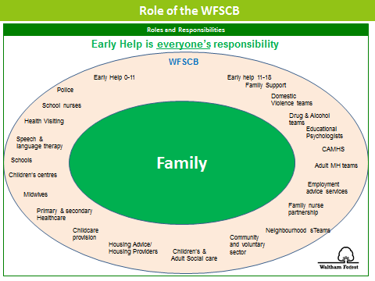
Practitioners can assess further advice and information from the website http://www.walthamforest.gov.uk/earlyhelp where a copy of the Early Help Assessment Form can be found. All the information for Early Help is on the hub and on the website http://www.walthamforest.gov.uk/Pages/Services/Social-care-Common-Assessment-Framework.aspx
Assessed need is recorded on the actual Early help Assessment and will be stored centrally by the Early Help Service when submitted to the inbox: EarlyHelp@walthamforest.gov.uk

The Early Help Co-ordinators will assist you with your EHA and convening initial Team around the Family Meetings (TAFs) where a case is complex. In most cases, this will allow for the co-ordination of all appropriate services with an identified Lead Professional for the family.
Early Help Co-ordinators and their email addresses:

North: Janice Bryden Janice.Bryden@walthamforest.gov.uk
Central: Jo McBride Joanne.McBride@walthamforest.gov.uk
South: Rebecca Whitney Rebecca.Whitney@walthamforest.gov.uk

It is recognised that for some families to “receive the right help at the right time”, additional support may be needed from the LA’s Early Help service or from Children’s Social Care before an Early Help Assessment has been concluded by using the single request for help and support or protection. The request for Help, Support and Protection form also acts as the first part one of the Early Help Assessment and dovetails with it so that the assessment can be continued by the school practitioner if appropriate, in the future.
There will be varying degrees of consent in some cases i.e. consent to do the EHA but only shared with certain people. Consent should always be discussed with parents and their wishes respected. Communication and engagement with parents is critical to informed consent. It is hoped in the majority of cases parents will see the EHA as something supportive and helpful.

The request for Help, Support and Protection form is available for the website: http://www.walthamforest.gov.uk/earlyhelp
https://www.walthamforest.gov.uk/pages/servicechild/mash-professionals.aspx#ReferralstoMASH

Contact MASH
MULTI AGENCY SAFEGUARDING HUB (MASH) – CONTACT:
Phone: 020 8496 2310 (Monday - Thursday 9am-5.15pm and Fri 9am-5pm)
Mob: Tel: 020 8496 3000 (Out of Hours)
Fax: 020 8496 2313
Email: MASHrequests@walthamforest.gov.uk
Waltham Forest Multi Agency Safeguarding Hub
221 Hoe Street,
Walthamstow
London
E17 9PH
Phone: 020 8496 2310 (Mon-Thurs, 9am-5.15pm and Fri, 9am-5pm)
Mob: 020 8496 3000 (out of hours)
Txt:
Fax: 020 8496 2313
Email: MASHrequests@walthamforest.gov.uk

Allegations regarding person(s) working in or on behalf of the school (including volunteers)
When an allegation is made against a member of staff, set procedures must be followed. It is rare for a child to make an entirely false or malicious allegation, although misunderstandings and misinterpretations of events do happen.

A child may also make an allegation against an innocent party because they are too afraid to name the real perpetrator. Even so, we must accept that some professionals do pose a serious risk to pupils and we must act on every allegation.

Staff who are the subject of an allegation have the right to have their case dealt with fairly, quickly and consistently and to be kept informed of its progress. Suspension is not the default option and alternatives to suspension will always be considered. In some cases, staff may be suspended where this is deemed to be the best way to ensure that children are protected. In the event of suspension, the school will provide support and a named contact for the member of staff.

The full procedures for dealing with allegations against staff can be found in Keeping Children Safe in Education (DfE, 2020) and in the school’s Managing Allegations policy and procedures.

Staff, parents and governors are reminded that publication of material that may lead to the identification of a teacher who is the subject of an allegation is prohibited by law. Publication includes verbal conversations or writing, including content placed on social media sites.

Allegations concerning staff who no longer work at the school, or historical allegations will be reported to the police.
Where an allegation is made against any person working in or on behalf of the school that he or she has:
- behaved in a way that has harmed a child or may have harmed a child;
- possibly committed a criminal offence against or related to a child; or
- behaved towards a child or children in a way that indicates he or she would pose a risk of harm if they work regularly or closely with children (refer to statutory guidance for schools and colleges; Keeping Children Safe in Education (2020)
We will apply the same principles as in the rest of this document, as well as always follow the procedures outlined in the above-mentioned document. This includes allegations against staff in their personal lives.
Whilst we acknowledge such allegations, (as all others), may be false, malicious or misplaced, we also acknowledge they may be founded. It is, therefore, essential that all allegations are investigated properly, in line with agreed procedures and outcomes recorded.
The name of any member of staff considered to be not suitable to work with children will be notified to the DfE, with the advice and support of Human Resources and in accordance with the NEOST guidance and related regulations.
Initial Response to an allegation or concern:
Initial Action by person receiving or identifying an allegation or concern
- Treat the matter seriously and keep an open mind
- Make a written record of the information using the Record Form on CPOMS https://stmaryswaltham.cpoms.net/ including the time, date and place of incident/s, persons present and what was said and sign and date this
- Immediately report the matter to the most senior person in the organization.

Initial Action by the Designated Safeguarding Lead (The DSL will normally be the Head Teacher). If the DSL is the subject of the allegation, then the Chair of Governors will take the following action.

- Obtain written details of the concern or allegation, but do not investigate or interview child, adult or witnesses
- Contact the LADO within 1 working day
- Discuss with the LADO next steps using the London Child Protection Procedures Flow Charts Allegations/Concerns Against Staff (Appendix 9)
- Inform the Chair of Governors of the allegation
Subsequent Action by the Designated Safeguarding Lead
  - Conduct a disciplinary investigation, if an allegation indicates the need for this
  - Contribute to the child protection process by attending professional strategy meetings
  - Maintain contact with the LADO
  - Ensure clear and comprehensive records regarding the allegation, and action taken and outcome are retained on the staff member’s personnel file
  - Consider along with Human Resources and the LADO whether a referral to the DBS should be made.
Peer on Peer Abuse
Our school recognises that the harm caused to children by the harmful and bullying behaviour of other children can be very significant.
Children who harm others should be held responsible for their harmful behaviour and the school staff are alerted to the fact that they are likely to pose a risk to other children in the school, home and community. All staff should have an awareness of what constitutes Peer on Peer abuse. This is most likely to include, but may not be limited to, verbal or physical bullying; cyber-bullying; sexual violence/harassment and sexting; and initiation/hazing type violence and rituals. While peer on peer abuse between children is not a separate category of abuse and neglect, it is a very serious issue that can cause considerable anxiety and distress. At its most serious level, peer on peer abuse can have a disastrous effect on a child’s wellbeing.
All incidences of peer on peer abuse should be reported immediately and will be managed through our tackling-bullying procedures. All pupils and parents receive a copy of the procedures on joining the school and the subject of bullying is addressed at regular intervals in PSHE education and in assemblies so as to minimise the risk of peer on peer abuse taking place.
Where harm involves sexual abuse, serious physical or serious emotional abuse, the safeguarding procedures set out in this policy will be applied.
This school recognises that children who harm others are likely to have considerable needs themselves and may have experienced or be experiencing significant harm themselves.
It is crucial that peer on peer abuse, including sexual peer on peer abuse, is not tolerated or passed off as “banter” or “part of growing up”. Also, whilst the majority of victims of sexual harassment/violence will be female, all peer on peer abuse of this type will be treated as unacceptable and will be taken seriously.
Upskirting is a form of peer on peer abuse. ‘Upskirting’ typically involves taking a picture under a person’s clothing without them knowing, with the intention of viewing their genitals or buttocks to obtain sexual gratification, or cause the victim humiliation, distress or alarm. It is now a criminal offence.
Victims of peer on peer abuse should not be made to feel ashamed that they have reported an incident. When there has been a report of sexual harassment or violence, a risk assessment will be completed by the DSL with consideration given to the protection and support required by both the victim and alleged perpetrator, and any other children involved. The school will also consider the wishes of the victim in terms of how they want to proceed; the nature of the alleged incident; the ages of the children involved; the development stages of the children involved; any power imbalance between the children; whether the incident is a one-off or a sustained pattern of abuse; ongoing risks to the victim, other children, school staff; and any ‘contextual safeguarding’ issues.
The DSL will liaise with children’s social care and specialist services where required. Some cases, depending on the circumstances, will be dealt with either internally or through the offer of Early Help.
If the school has concerns about a child exhibiting sexualised or harmful sexual behaviour they will first screen the incident(s) using the ‘AIM for Education Settings’ tool (unless the incident warrants immediate police intervention). The outcome of this assessment will guide the school with regard to subsequent referrals, internal risk management, strategies and intervention. If there is no AIM trained member of staff available to complete this assessment, the school will refer to key officers in the local authority (currently Krishna Ridley-Lee, HSB lead and Julia Kent, Social Inclusion Service).
Unless the outcome of the assessment is ‘Healthy’, the school will then compile a chronology of relevant incidents to support pattern mapping. This will then inform the school’s Safety and Support plan both for the child that has harmed and the child that has been harmed. Throughout the process it is desirable that parents are engaged and informed. The local authority HSB lead, the Education Co-ordinator and other key officers are available to provide support, which is supplemented by detailed guidance and support in the AIM for Education Settings manual.
Please see the attached flow chart in Appendix for further guidance
Harmful Sexual Behaviour (HSB): Local Authority Support for Schools
This section is designed to show;
1) the support currently available to schools for responding to and managing problematic and harmful sexual behaviour and sexual bullying;
2) the route to follow if you are responding to an incident or pattern of HSB.
Much of the assessment guidance and resources derive from the AIM Project, who provide a range of training in this area. Most schools will have a member of staff trained in the AIM Education Guidelines and an AIM Manual: if you are unsure who this is, or would like further information about training, please don’t hesitate to contact me.
Key Contacts
Julia Kent | HSB Education Co-ordinator | 020 8496 1742
Julia.Kent@walthamforest.gov.uk
Tracey Goddard | LA Lead, HSB | 07974 768 433
Tracey.Goddard@walthamforest.gov.uk
Lisa Witherden | LA Lead, Child Sexual Exploitation (CSE) | 07715 901 256
LisaWitherden@saferlondonfoundation.org
Amy Coates | Public Health, Healthy Schools
Amy.coates@walthamforest.gov.uk
Samantha Norwood | Family Planning Nurse | 07872 048 256
Samantha.Norwood@nelft.nhs.uk
Sue Hargreaves | Targeted Youth Support Service
Sue.Hargreaves@walthamforest.gov.uk
Dwayne Gumbs | Creative Director, Diverse Voices
dwayne@diversevoices.co.uk
Jessica Aldridge | NIA - Young Women and Girls’ Advocate | 020 7683 1270
Jaldridge@niaendingviolence.org.uk
Restorative Intervention Officers: Contact Julia Kent or
Peter Akubuko (Central Area Secondary Schools)
Peter.Akubuko@walthamforest.gov.uk
Grit Kalkowski (North Area Secondary Schools)
Grit.Kalkowski@walthamforest.gov.uk
Estella Maselino (South Area Secondary Schools)
Estella.Maselino@walthamforest.gov.uk

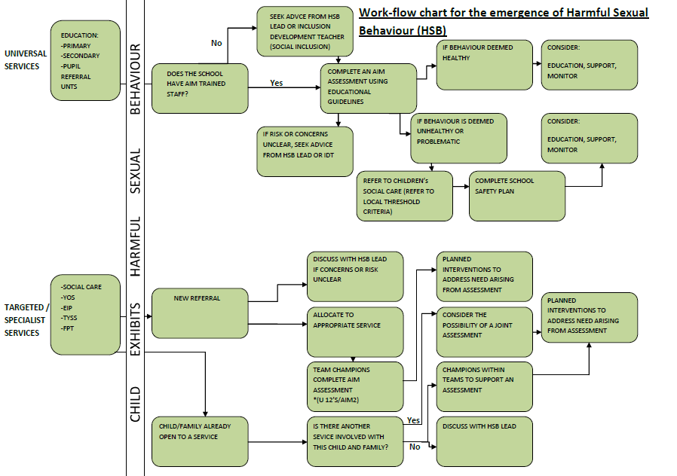
Appendix 2
* This list is not exhaustive; refer to practitioners named for more information.

Response | UNIVERSAL | TARGETED | SPECIALIST
PROTECTIVE

ASSESSMENT

INTERVENTION (including those harmed)

MANAGEMENT

* This list is not exhaustive; refer to practitioners named for more information.

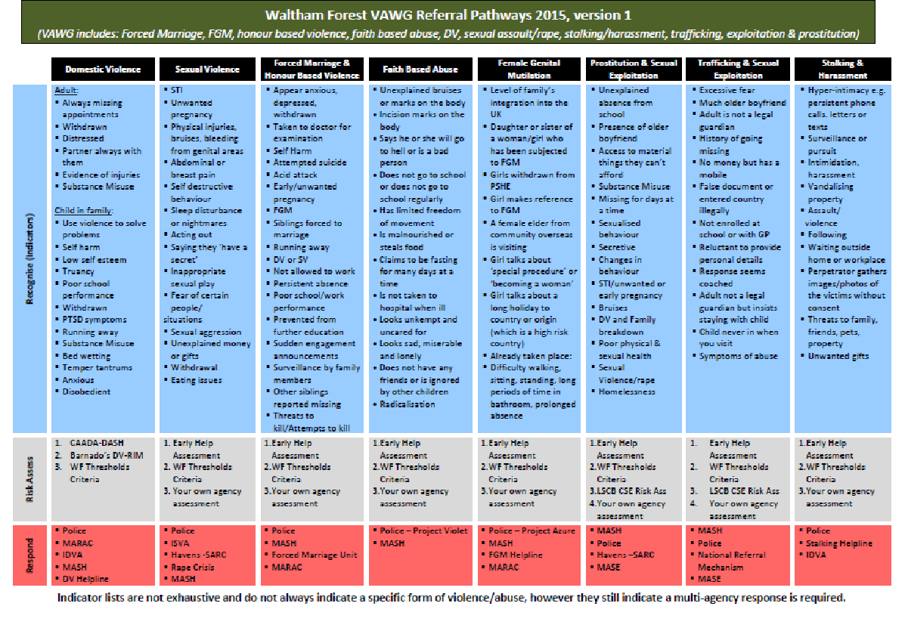

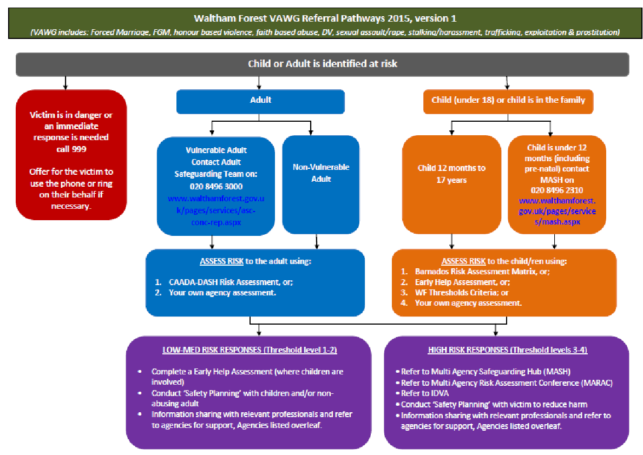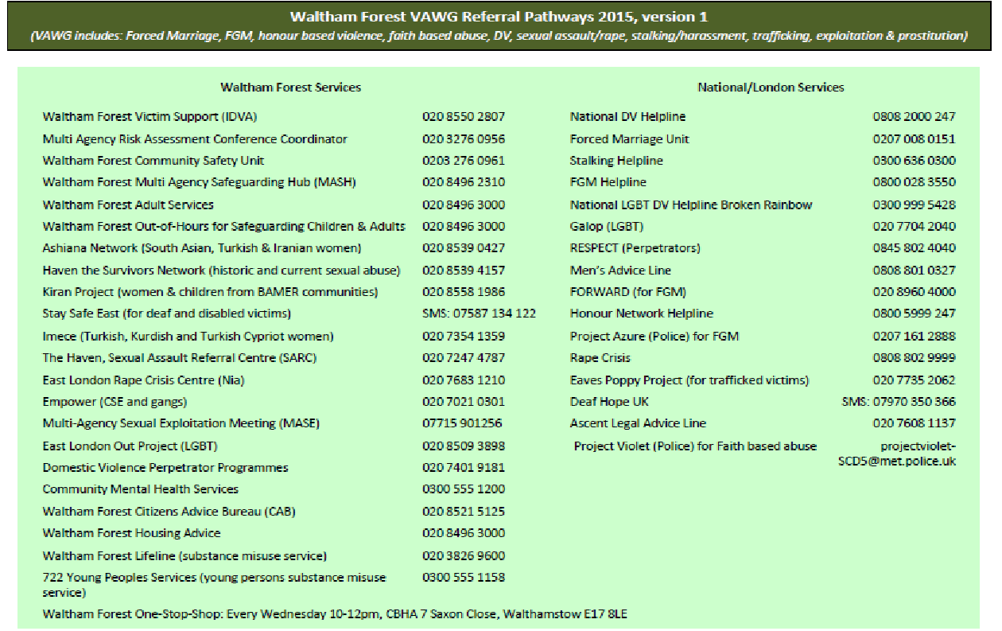

Appendix 2 (updated from KCSiE 2018)

Appendix 3
Key contacts for child protection issues in Waltham Forest
The following details relate to key personnel in Child Protection who can be contacted should any child protection issues arise.
Name |  | Agency |  | Contact details
Designated Doctor for Child Protection |  | North East London Foundation Trust (NELFT) |  | 020 8430 7893  07795 548987
Named Nurse for Safeguarding – Community Health Services, School Nursing, Health Visitors and Child & Adolescent Mental Health Services (CAHMS) |  | North East London Foundation Trust (NELFT) |  | 020 8430 7827/7822  07568 130143  Fax: 020 8430 7981
Named Nurse for Safeguarding |  | Barts Health at Whipps Cross University Hospital Paediatric A&E |  | 020 8535 6855 bleep 514  Pager: 08700555500 ask for 850122  Secretary: Ext 5072
Police Referral Desk |  | Metropolitan Police Child Abuse & Investigation Team (CAIT) |  | 020 8345 3633  020 8345 3693
Designated Nurse for Safeguarding Children – GP Services |  | Clinical Commissioning Group (CCG) |  | 020 3688 2638
Divisional Director for Children & Families Services |  | Waltham Forest Children & Families Services |  | 020 8496 3206
Head of Service – Quality Assurance (QA)Service |  | Waltham Forest Children & Families Services |  | 020 8496 3685
Deputy Head of Service – Quality Assurance (QA) Service |  | Waltham Forest Children & Families Services |  | 020 8496 3250
Duty Child Protection Co-ordinators – Quality Assurance (QA) Service |  | Waltham Forest Children & Families Services |  | 020 8496 8279
Local Authority Designated Officer (LADO) – Quality Assurance (QA) Service |  | Waltham Forest Children & Families Services |  | 020 8496 3646
Safeguarding in Education Service |  | Waltham Forest Children & Families Services |  | 020 8496 6310  020 8496 8277
Head of Service – Children’s Safeguarding & Family Support Service |  | Waltham Forest Children & Families Services |  | 020 8496 8393
Deputy Heads of Service – Children’s Safeguarding & Family Support Service |  | Waltham Forest Children & Families Services |  | 020 8496 1375  020 8496 2338
Waltham Forest Multi Agency Safeguarding Hub (MASH) Team/Children’s Referral & Advice Team  Team Manager – Waltham Forest Multi Agency Safeguarding Hub (MASH) Team/Children’s Referral & Advice Team  Team Manager – Children’s Emergency Duty |  | Waltham Forest Children & Families Services  Waltham Forest Children & Families Services |  | cscreferrals@walthamforest.gov.uk  020 8496 2313 (Fax)  020 8496 2307/10/11/16/17  020 8496 2317  020 8496 3000

Appendix 4

SAFEGUARDING CHILDREN: WHISTLEBLOWING
WHISTLEBLOWING POLICY

- INTRODUCTION
- Employees are often the first to realise that there may be something seriously wrong within the GET. However, they may not express their concerns because they feel that speaking up would be disloyal to their colleagues or to the GET. They may also fear harassment or victimisation. In these circumstances it may be easier to ignore the concern rather than report what may just be a suspicion of malpractice.
- The GET is committed to the highest possible standards of openness, probity and accountability. In line with that commitment we expect employees, and others that we deal with, who have serious concerns about any aspect of the GET's work to come forward and voice those concerns. It is recognised that most cases will have to proceed on a confidential basis.
- The policy document makes it clear that you can do so without fear of victimisation, subsequent discrimination or disadvantage. This whistle-blowing policy is intended to encourage and enable employees to raise serious concerns within the GET rather than overlooking a problem or 'blowing the whistle' outside.
- The policy applies to all employees and those contractors working for the GET on GET premises, for example, agency staff, consultants, etc. It also covers suppliers and those providing services under a contract with the GET.
- These procedures are in addition to the GET's complaints procedures and other statutory reporting procedures. You are responsible for making Parents aware of the existence of these procedures.
- AIMS AND SCOPE OF THIS POLICY
This policy aims to:
- encourage you to feel confident in raising serious concerns and to question and act upon concerns about practice
- provide avenues for you to raise those concerns and receive feedback on any action taken
- ensure that you receive a response to your concerns and that you are aware of how to pursue them if you are not satisfied
- Reassure you that you will be protected from possible reprisals or victimisation if you have a reasonable belief that you have made any disclosure in good faith.
- There are existing procedures in place to enable you to lodge a grievance relating to your own employment. The whistle-blowing policy is intended to cover major concerns that fall outside the scope of other procedures. These include but are not limited to:
    - conduct which is an offence or a breach of law
    - disclosures related to miscarriages of justice
    - the unauthorised use of public funds
    - possible fraud and corruption
    - other unethical conduct
- Thus, any serious concerns that you have about any aspect of service provision or the conduct of Governors and Staff of the GET or others acting on behalf of the GET can be reported under the whistle-blowing policy. This may be about something that:
    - makes you feel uncomfortable in terms of known standards, your experience or the standards you believe the GET subscribes to; or
    - is against the GET's Standing Orders, regulations and policies; or
    - falls below established standards of practice; or
    - amounts to improper conduct.
- This policy does not replace the corporate complaints procedure.
- SAFEGUARDS
- Harassment or Victimisation
  - The GET is committed to good practice and high standards and wants to be supportive of employees.
  - The GET recognises that the decision to report a concern can be a difficult one to make. If what you are saying is true, you will have nothing to fear because you will be doing your duty to your employer and those for whom you are providing a service.
  - The GET will not tolerate any harassment or victimisation (including informal pressures) from your colleagues, peers, managers or from external sources, and will take appropriate action to protect you when you raise a concern in good faith.
  - Any investigation into allegations of potential malpractice will not influence or be influenced by any disciplinary or redundancy procedures that already affect you.
- Confidentiality
  - All concerns will be treated in confidence and the GET will keep your identity confidential if you so wish. At the appropriate time, however, you may need to come forward as a witness.

4 ANONYMOUS ALLEGATIONS
4.1 This policy encourages you to put your name to your allegation whenever possible.
4.2 Concerns expressed anonymously are much less powerful but will be considered at the discretion of the GET.
4.3 In exercising this discretion the factors to be taken into account would include:
- the seriousness of the issues raised
- the credibility of the concern; and
- the likelihood of confirming the allegation from attributable sources.
- UNTRUE ALLEGATIONS
  - If you make an allegation in good faith, but it is not confirmed by the investigation, no action will be taken against you. If, however, you make an allegation frivolously, maliciously or for personal gain, disciplinary action may be taken against you.
- HOW TO RAISE A CONCERN
- As a first step, you will normally raise concerns with your immediate manager or their superior. This depends, however, on the seriousness and sensitivity of the issues involved and who is suspected of the malpractice. For example, if you believe that management is involved you will approach the:-
- Chair of the Board – Canon Ade Ademola
- The Chief Executive – Mrs Beverley Hall on 020 8521 1066/8520 0612
- Chief Operations Officer– Mrs Elaine James – on 020 8521 1066
or externally to Buzzacot, 130 Wood Street, London, EC2V 6DL

  - Concerns may be raised verbally or in writing. Staff who wish to make a written report are invited to include the following information:
- the background and history of the concern (giving relevant dates);
- the reason why you are particularly concerned about the situation.
  - The earlier you express the concern the easier it is to take action.
  - Although you are not expected to prove beyond doubt the truth of an allegation, you will need to demonstrate to the person contacted that there are reasonable grounds for your concern.
  - Obtain advice/guidance on how to pursue matters of concern by telephoning any of the numbers above.
If ultimately you feel you have to take the matter externally to Haslers, possible contacts are listed at Section 9 of this policy.
  - You may wish to consider discussing your concern with a colleague first and you may find it easier to raise the matter if there are two (or more) of you who have had the same experience or concerns.
  - You may invite your trade union, professional association representative or a friend to be present during any meetings or interviews in connection with the concerns you have raised.
- HOW THE GET WILL RESPOND
  - The GET will respond to your concerns. Do not for that testing out your concerns is not the same as either accepting or rejecting them.
  - Where appropriate, the matters raised may:
- be investigated by management, or through the disciplinary process
- be referred to the police or other appropriate agency such as Her Majesty’s Revenue and Customs (HMRC) or the United Kingdom Borders Agency (UKBA)
- be referred to the GET’s external auditor, the Audit Commission
- form the subject of an independent inquiry.
  - In order to protect individuals and those accused of misdeeds or possible malpractice, initial enquiries will be made to decide whether an investigation is appropriate and, if so, what form it will take. The overriding principle which the GET will have in mind is the public interest. Concerns or allegations which fall within the scope of specific procedures (for example, child protection or discrimination issues) will normally be referred for consideration under those procedures.
  - Some concerns may be resolved by agreed action without the need for investigation. If urgent action is required this will be taken before any investigation is conducted.
  - Within ten working days of a concern being raised, the responsible person will write to you:
- acknowledging that the concern has been received
- indicating how we propose to deal with the matter
- giving an estimate of how long it will take to provide a final response
- telling you whether any initial enquiries have been made
- supplying you with information on staff support mechanisms, and
- telling you whether further investigations will take place and if not, why not.
  - The amount of contact between the officers considering the issues and you will depend on the nature of the matters raised, the potential difficulties involved and the clarity of the information provided. If necessary, the GET will seek further information from you.
  - Where any meeting is arranged, off-site if you so wish, you can be accompanied by a union or professional association representative or a friend.
  - The GET will take steps to minimise any difficulties which you may experience as a result of raising a concern. For instance, if you are required to give evidence in criminal or disciplinary proceedings the GET will arrange for you to receive advice about the procedure.
  - The GET accepts that you need to be assured that the matter has been properly addressed. Thus, subject to legal constraints, we will inform you of the outcome of any investigation.
- THE RESPONSIBLE OFFICER
  - The Chief Executive has overall responsibility for the Whistleblowing Policy. The day to day maintenance and operation of the policy will be undertaken by the Heads of School. The Heads of School maintain a record of concerns raised and the outcome (but in a form which does not endanger your confidentiality) and will report as necessary to the Directors of the GET.
- HOW THE MATTER CAN BE TAKEN FURTHER
  - This policy is intended to provide you with an avenue within the GET to raise concerns. The GET hopes you will be satisfied with any action taken. If you are not, and if you feel it is right to take the matter outside the GET, the following are possible contact points:
- Public Concern at Work (tel: 020 7404 6609), a registered charity whose services are free and strictly confidential
- the external auditor
- your trade union
- your local Citizens Advice Bureau
- relevant professional bodies or regulatory organisations
- a relevant voluntary organisation
- the police.
  - If you do take the matter outside the GET, you will ensure that you do not disclose confidential information.

Appendix 5

All concerns are now to be logged electronically using CPOMS – https://stmaryswaltham.cpoms.net/

If a visitor raises a concern, this will be logged using CPOMS with the support of a member of schools staff who has sufficient DSL training.

Appendix 6
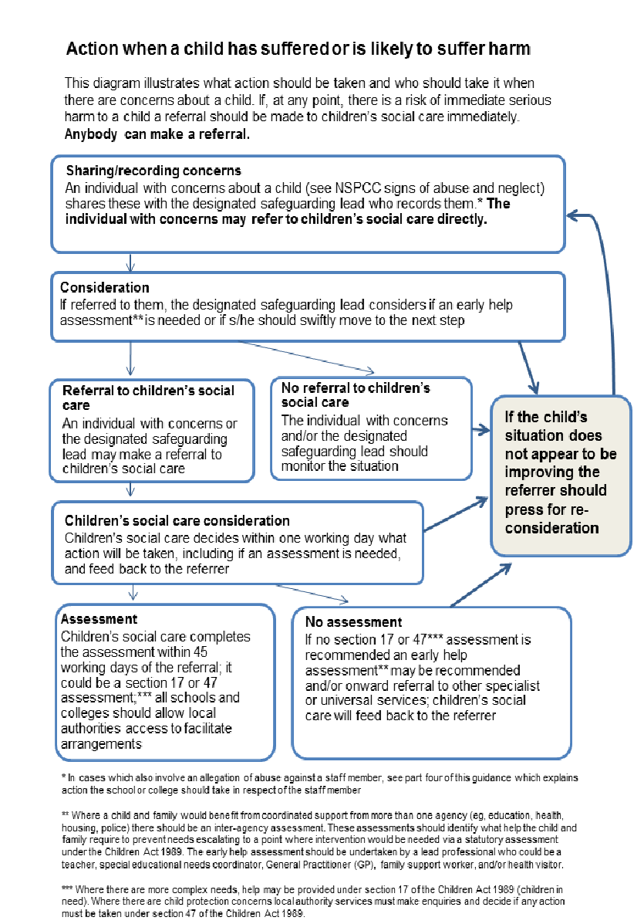

Early Help Assessment Form

Guidance

This is the Waltham Forest Early Help Assessment Form to provide early help for children and their families. This form is to
support sufficient analyses or focus on what the child and family need.

This form should be completed and sent to: Tel: 020 8496 2310 I Email: EarlyHelp@walthamforest.gov.uk

Please ensure that you complete this form for all members of the family to ensure that as full a picture as possible is gained of their needs, risks and strengths and an appropriate level of co-ordinated, multi-agency support is therefore provided”

If at any time during the course of this assessment you feel that a child in the family has been harmed or abused or is at risk of harm or abuse, you must follow the local safeguarding children board procedures. Record details of unborn baby, infant, child or young person being assessed. If unborn, state name as ‘unborn baby’ and mother’s name e.g. unborn baby of Ann Smith.

If you encounter any difficulties in relation to your Early Help Assessment, please contact the Early Help Co-ordinators as part of the MASH Team, on telephone: 020 8496 2310

For further guidance, please refer to the Early Help web page: http://www.walthamforest.gov.uk/earlyhelp

For urgent matters, please contact the Waltham Forest Multi-Agency Safeguarding Hub (MASH) on 020 8496 3000

Section A – Contact Details

Details of person making contact
Name:
Agency / Team:
Role / Job title:
Address
Contact Number(s):
Date of this request:

Consent / Information sharing:
Note: Consent must always be sought unless it puts a child at further risk to do so.

Has the parent or child / young person consented to the requested being made | YES | ☐ | NO | ☐

The child / young person knows about the referral: | YES | ☐ | NO | ☐
If no, please state the reason(s):

The parent / carer knows why the referral is being made: | YES | ☐ | NO | ☐
If no, please state the reason(s):

The parent / carer understands and agrees to agencies sharing information: | YES | ☐ | NO | ☐
If no, please state the reason(s):
Section B– Family details
Add details of all subject(s) Child / Young Person.
•UPN - Unique Pupil Number
•Other Name(s) – Aliases/ Also Known As/ Previous Name(s)
•DOB – Date of Birth
•EDD – Expected Date of Delivery
•EHC – Education, Health & Care plan
Note: A statement of special Educational Needs, has been replaced by an EHC plan as of 1st Sep 2014

Details of subject child / young person:

NHS ID | UPN ID | First name | Surname | DOB / EDD | Age | Gender | Address | Ethnicity | Religion | Has EHC plan

Does the child/children have any known disabilities?

Details of family / household members:

First Name | Surname | DOB / EDD | Age |  | Gender | Address | Relationship with subject(s) | Parental Responsibility | Ethnicity | Religion

Details of other significant people not living in the household:

First Name | Surname | DOB / EDD | Age | Gender | Address | Relationship with subject(s) | Parental Responsibility | Ethnicity | Religion

Communication needs (including language) regarding any of the people named above

Legal status / Immigration status regarding any of the people names above:

Presenting issues

Please select all presenting issues that apply

Pre-selected presenting issues come from the ‘Contacts and Referral’ form
Abuse / Neglect Emotional Abuse | ☐ | Abuse/ Neglect – Neglect | ☐ | Abuse / Neglect – Physical Abuse | ☐
Abuse / Neglect Sexual Abuse | ☐ | Alcohol Misuse | ☐ | Emotional Neglect | ☐
Beyond Parental Control | ☐ | Challenging Behaviour | ☐ | Child / Young Person In Need | ☐
Child Missing Education | ☐ | Domestic Abuse | ☐ | Drugs Misuse Forced | ☐
Elective Home Education | ☐ | Female Genital Mutilation | ☐ | Marriage Intentionally | ☐
Gangs | ☐ | Honour Based Violence | ☐ | Homeless | ☐
Learning Disability | ☐ | Mental Health | ☐ | Missing from Education | ☐
Missing from Home | ☐ | No Recourse to Public Funds | ☐ | Physical Disability or illness | ☐
Privately Fostered | ☐ | Protection / At Risk | ☐ | Self-Harm | ☐
Sexual Harmful Behaviour | ☐ | Sexual Exploitation | ☐ | Socially Unacceptable Behaviour | ☐
Trafficking | ☐ | Unaccompanied Asylum Seeking Children | ☐ | Under 16 Year Old Pregnancy | ☐
Violent Extremism/Radicalisation | ☐ | Young Carer | ☐ | Anti-social Behaviour | ☐

Parent / Carer
Alcohol Misuse | ☐ | Domestic Abuse | ☐ | Drug Misuse | ☐
Intentionally Homeless | ☐ | Learning Disability | ☐ | Intentionally Homeless | ☐
No Recourse to Public Funds | ☐ | Physical Disability or illness | ☐

General:
Alcohol Misuse | ☐ | Domestic Abuse | ☐ | Drug Misuse | ☐
Family Breakdown | ☐ | Family Dispute | ☐ | Financial Support | ☐
Learning Disability | ☐ | Mental Health | ☐ | Physical Disability or illness | ☐

Details of lead professional:

Name:
Agency / Team
Role / Job title
Address
Contact Number(s):
E-mail Address

Details of practitioner undertaking this assessment (if not the lead professional):

Name:
Agency / Team
Role / Job title
Address
Contact Number(s):
E-mail Address

Services / Involved Professionals working with the family at present:

Key agencies involved: Add name, agency and contact details of all professional involved at present
Name | Role | Agency | Address | Contact number(s) | Email address

Section- C Assessment Information

Type of assessment | Initial | ☐ | Review | ☐
Date of this assessment

People present and/ or engaged in this assessment:

Child/Young person’s development needs

Consider each of the elements to the extent they are appropriate in the circumstances for each child in the family. Please ensure information is included on each member of the family and please include strengths as well as needs

Health | Child 1 | Child 2 | Child 3 | Child 4 | Child 5
Child’s Name
General Health:
Physical development
Speech, language and communication:
Emotional and social development:
Behavioural development:
Identity, self-esteem, self-image and social presentation:
Family and social relationships:
Self-care skills and independence:

Learning | Child 1 | Child 2 | Child 3 | Child 4 | Child 5
Understanding, reasoning and problem solving:
Participation in learning, education and development:
Progress and achievement in learning:
Aspirations:

Family & Environmental Factors
Family history, relationships and well-being
Wider Family:
Housing, employment and financial considerations:
Social and community resources, including education:

Parenting | Child 1 | Child 2 | Child 3 |  | Child 4 |  | Child 5
Parent/Carer Name
Basic care, ensuring safety and protection:
Emotional warmth and stability:
Guidance, boundaries and stimulation:

Early Help Assessed Issues: assessed issues are in addition to any presenting issues identified during the assessment process.
Adult in family with a learning difficulty | ☐ | Adult offender in the household | ☐ | Adult in the family on out of work benefits | ☐
Antisocial behaviour in the household | ☐ | School attendance issues | ☐ | Adult with a physical or debilitating illness | ☐
Abuse / Neglect Emotional Abuse | ☐ | Abuse/ Neglect – Neglect | ☐ | Abuse / Neglect – Physical Abuse | ☐
Abuse / Neglect Sexual Abuse | ☐ | Alcohol Misuse | ☐ | Emotional Neglect | ☐
Child Mental health issues | ☐ | Child substance misuse (Alcohol) | ☐ | 16/17 Year old not in employment, education or training | ☐
Child with a learning difficulty | ☐ | Child with a physical illness | ☐ | Child substance misuse (Drugs) | ☐
Domestic Abuse – Victim | ☐ | Gang Affiliation | ☐ | Domestic Abuse – Perpetrator | ☐
Parental Mental health issues | ☐ | Parental substance misuse | ☐ | Parental or older sibling in prison | ☐
Previous looked after child | ☐ | Risk of Eviction | ☐ | Parental Substance Misuse (Drugs) | ☐
Teenage Parent | ☐ | Young offender | ☐ |  | ☐
Other (specify below)

Assessment Tools

Name | Tool: | Completed: | Completed by: | Date Completed:
Conclusion and Actions

Conclusion:

Now the assessment is completed you need to record conclusions, solutions and actions. Work with the family and take account of their ideas, Solutions and goals

What are the child / young person and/or family strengths and resources? What are their needs? E.g. no additional needs or complex
needs. What are your conclusions?

N

Needs, Analysis and evaluation

What are your conclusions and analysis: What are the child / young person and/or family strengths and resources? What are their needs? E.g. no additional needs or complex needs.

What needs to change: Include the Child / Young persons, Parent’s / Carer’s and Practitioner’s views.
Child / Young person’s comment(s) on the assessment:
Persons Name
Comments

Parent’s / Carer’s comment(s) on the assessment:
Persons Name
Comments

Outcomes

Please select all the outcomes that apply
Education and Training | ☐ | Improved Attainment | ☐ | Behavioural Support | ☐
Improved family functioning | ☐ | Improved Health and Well-being | ☐ | Improved Housing and conditions | ☐
Improved Mental health | ☐ | Improved parenting | ☐ | Improved presentation | ☐
Improved school attendance | ☐ | Improved speech and language | ☐ | Improved management of behaviour | ☐
Parent into path to work | ☐ | Parent into work | ☐ | Reduced Alcohol and Drug misuse | ☐
Reduced ASB | ☐ | Reduced debt | ☐ | Reduced isolation | ☐
Reduced Offending | ☐ | Reduced risk taking behaviour | ☐ | Reduced safeguarding concerns | ☐
Reduced school exclusions | ☐ | Stabilising care arrangements | ☐ | Young person into work | ☐
Other (specify below)

Actions

Please select all actions that apply
Accessing identified services | ☐ | Advice and information | ☐ | Behavioural support | ☐
Bronze programme | ☐ | Carers / Young carer’s assessment | ☐ | Case closed | ☐
Disability support | ☐ | Domestic abuse support | ☐ | Drug and alcohol misuse support | ☐
Education and Training Support | ☐ | Financial advice and support | ☐ | Functional Family Therapy | ☐
Housing support | ☐ | Parenting programme | ☐ | Mental health support | ☐
Moved out of area | ☐ |  | ☐ | Transferred to another service | ☐
Signpost to team (specify below) | ☐ | Signpost to Agency (specify below) | ☐ | Other (specify below) | ☐

Signpost to Team: | Signpost to Agency:
Early Help Plan

People involved in this plan:
Agency or Family | Name (Full Name and Surname) | Role
Date of this plan

Action Plan

Family member Name | Outcomes | Actions | Comments | Who will be responsible | Date to be completed

Final Summary

Additional information:
Comment(s) Child / Young person’s comments on the outcomes / actions identified:
Comment(s) Parent / Carer’s comments on the outcomes / actions identified:

Arrangements for review:
Planned Date:
Planned Time:
Venue

Appendix 7
Waltham Forest Children and Families Service
Children’s social care Multi Agency Referral Form (MARF)
GUIDANCE NOTES TO REFERRERS
- Colleagues in other agencies should always use this form to make a referral to Children’s Social Care, inclusive of a Child in Need (under Section 17 of the Children Act 1989) and a Child in Need of protection (under Section 47 of the Children Act 1989).
- This form should be used to record whether a parent or young person’s consent has been obtained to a referral being made.
- Using this format enables the service to respond promptly by supplying necessary information.
- Urgent referrals where a child is at risk of significant harm can be made by telephone, and then immediately followed up with this form.
- Please see the leaflet ‘Making a Good Referral and What Happens Next; A Threshold Criteria Tool’ which provides information and advice about how to make a good referral. www.walthamforest.gov.uk/Pages/ServiceChild/mash-professionals.aspx
- Waltham Forest has accepted the London Safeguarding Children Board thresholds for referral to children’s social care www.londonscb.gov.uk.
Colleagues should also make reference to The London Borough of Waltham Forest Safeguarding Children’s Board ‘Early Help and Threshold Criteria for Intervention’ document which provides a locality response to our children and young people’s needs. www.walthamforest.gov.uk/Pages/ServiceChild/mash-professionals.aspx

- Before referring a child to children’s social care, professionals who work with children and families should consider where appropriate undertaking a Common Assessment Framework or Team around the child meeting, that includes relevant referrals to appropriate specialist services for support and assistance.
- If this course of action does not address the issues effectively or needs and risks increase, referral to social care should then be considered.
- If a child is at risk of harm an immediate referral can be made, however any CAF information would still be relevant and contribute to the on-going assessment.
This form should be emailed, faxed or posted to the MASH team:
MASH, Juniper House, 221 Hoe Street, Walthamstow, E17 9PH
Tel: 0208 496 2310
Fax : 0208 496 2313
Email: cscreferrals@walthamforest.gov.uk

FEEDBACK TO REFERRERS
- We will ensure that your referral reaches the correct team and that you receive a written response to your referral within 24 hours. This is automatically generated by Framework i
- If you do not hear back from us regarding the outcome and/or progress of your referral, please contact the MASH Administrator on 0208 496 2310 who will inform you of the outcome of your referral.
- If you encounter any difficulties in relation to your referral that you wish to bring to the attention of a senior manager, please contact the Head of Service for Safeguarding and Family Support on 0208 496 2310

DETAILS OF THE CHILD/REN BEING REFERRED |  |  |  |  |  | Ethnicity |  |  |  |  |  | Language spoken
First name | Surname |  |  |  | Date of birth |  |  |  | Gender
 |  |  |  |  |  |  |  |  | Male☐ Female☐
 |  |  |  |  |  |  |  |  | Male☐ Female☐
 |  |  |  |  |  |  |  |  | Male☐ Female☐
Address |  |  |  |  |  |  |  |  |  |  |  |  | Telephone
 |  |  |  |  |  |  |  | Postcode
CHILD/YOUNG PERSON’S PRINCIPAL CARERS |  |  |  |  |  |  |  |  |  |  |  |  |  |  |  |  |  | Parental Responsibility
FULL NAME |  |  | DOB  If Known | Relationship to child |  |  |  |  |  | Ethnicity  Code |  |  |  | Y / N
 |  |  |  |  |  |  |  |  |  |  |  |  |  | Y / N
 |  |  |  |  |  |  |  |  |  |  |  |  |  | Y / N
 |  |  |  |  |  |  |  |  |  |  |  |  |  | Y / N
First Language of carers: Is an interpreter or signer required? Y / N

Person making the referral:
Name |  |  |  |  |  |  | Agency
Address |  |  |  |  |  |  |  |  |  |  |  |  | Telephone
 |  |  |  |  |  |  |  | Postcode
As a rule the referring professional:
- needs to explain to parent/carer (who has parental responsibility) why they are making a referral to Children’s Services;
- needs to explain to the parent/carer (who has parental responsibility) that when the referral will be processed by Children’s Services, various agencies may be contacted and asked to share information to get a better picture of the child’s circumstances and to inform decision making;
- needs to justify not seeking parental consent to referral/ information sharing
 |  | Y / N |  |  |  |  |  |  |  |  | If no, please state reason
The child/young person knows
about the referral

The parent/carer knows about why the referral is being made

The parent/ carer understands and agrees to agencies sharing information

KEY AGENCIES INVOLVED
Insert name of professional if involved |  | Telephone number | Insert Name of professional if involved |  | Telephone  number
Health Visitor |  |  | General Practitioner
Nursery |  |  | Education Welfare Officer
School |  |  | Police
Youth Offending Team |  |  | Dentist
Community Mental Health |  |  | Community  Pediatrician
School Nurse |  |  | Housing
Probation |  |  | Other

REASON FOR REFERRAL/REQUEST FOR SERVICES
If an allegation of possible physical abuse, please give specific details of any injury including dates and explanations given
INFORMATION SUPPORTING THIS REFERRAL
The purpose of this section is to assist the inter-agency assessment. Where you have no information about a particular area please write - N/K. Record strengths as well as areas of need or risk so that resources can be directed appropriately.
Child/young person’s developmental needs and identified risk factors:
Consider health, emotional and behavioural development, education, identity, family and social relationships, social presentation and self-care.

Parent/carers’ capacities to respond to child/young person
Consider basic care, ensuring safety, emotional warmth, stimulation, provision of guidance and boundaries, and stability.
Issues affecting parent/carer’s capacity to respond appropriately to child/young person’s needs.
Family and environmental factors which impact on the child
Consider family history & functioning, the wider family, housing employment, income, the family’s social integration and the availability of community resources to provide support.
DETAILS OF REFERRER AND SOCIAL WORKER TAKING REFERRAL

Name of worker completing referral

(please print)

AGENCY

ADDRESS

TELEPHONE NUMBER

SIGNATURE |  |  | DATE

NAME OF SOCIAL WORKER

TAKING REFERRAL

TEAM |  |  | DATE

Appendix 8

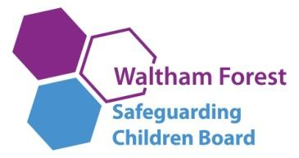
September 2019
Dear Colleague,

Re: How to escalate professional concerns about a child

I would like to advise you and staff in your organisation who have a child protection responsibility how to take action using the appropriate channels when you believe that your professional opinions have not been acted on appropriately. Please disseminate this advice widely to appropriate staff.

For example, if you have concerns regarding the lack of response to professional opinions and judgements expressed by your staff about safeguarding matters including concerns that social care services are not taking appropriate actions regarding the well-being of a child, or are not responding in a timely fashion to your concerns.

In the first instance please raise any concerns directly with the manager of the allocated social worker. If there is no allocated social worker please speak to the manager of referral and advice as below:

Children Social Care and Education

Team Manager MASH/Referral and Advice | 020 8496 2317

If you feel your concerns have still not been acted on appropriately then please escalate your concerns to the relevant head of service:

Head of Safeguarding and Family Support | 020 8496 1907
Deputy Head of Safeguarding and Family Support | 020 8496 1375
Head of Children in Care | 020 8496 8388
Deputy Head of Children in Care | 020 8496 2184
Head of Placement and Resources | 020 8496 2136
Deputy Head of Placement and Resources | 020 8496 2478
Head of Quality Assurance | 020 8496 3685
Deputy Head of Quality Assurance | 020 8496 8250

Where you remain concerned following your discussion with the head of service, a senior member of staff in your organisation should then speak to:

Divisional Director of Children and Families | 020 8496 3206

If you remain concerned, the most senior manager in your organisation should speak to the Deputy Chief Executive, Families Directorate:

Deputy Chief Executive, Families Directorate | 020 8496 3501

In the event that your concerns involve children social care in another local authority area, the above staff will contact the relevant staff in that organisation.

It is important that concerns are speedily escalated within the management structure for children’s social care until a satisfactory resolution of the concern is secured.

If you have any concerns related to the safeguarding practice of any other agencies, in the first instance please speak to the team manager of the practitioner, and if you remain concerned please contact the following. If you do not receive a satisfactory response please ask for the next appropriate manager to speak to.

Schools

Divisional Director Educational Improvement | 020 8496 3221

Barts Health at Whipps Cross Hospital

Named Nurse for Safeguarding | 020 8535 6855

Police

Detective Inspector, Sexual Offences, Exploitation and Child Abuse Command or next stage Detective Chief Inspector | 020 8217 6411/6471

Community health services, school nursing, health visitors, child and adolescent mental health services

Named Nurse for Safeguarding, NELFT | 020 8430 7827  M: 07738 803104

Community health Child Protection Doctor

Designated Doctor for Child Protection, NELFT | 0208 430 7883  M:07795 548987

Waltham Forest Clinical Commissioning Group (WFCCG)

Designated Nurse for Safeguarding, WFCCG | 020 3688 2681  M:07538798129
Designated Nurse for Looked After Children, WFCCG | 020 3688 2670  M:07930195306

If you have any general enquiries about the contents of this letter, please contact Suzanne Elwick, Waltham Forest Safeguarding Children Board, Business Manager, 020 8496 3683, suzanne.elwick@walthamforest.gov.uk.

Please bring this letter to the attention of all staff.

Yours sincerely

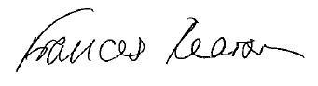
Fran Pearson WFSCB Independent Chair

Appendix 9
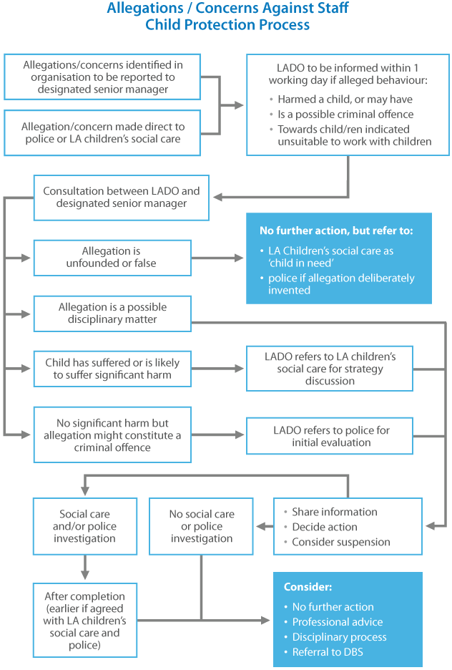
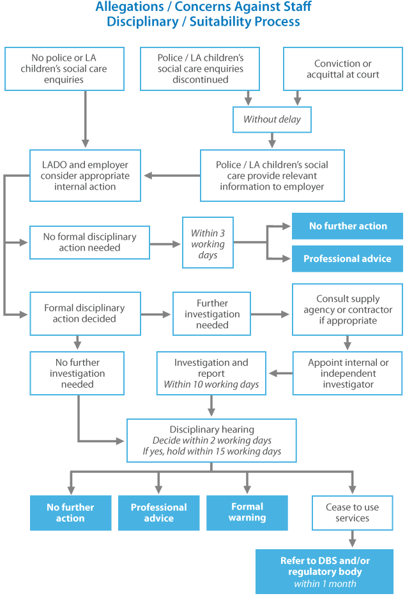

This website has been designed and is powered by tri.x and is the copyright of the London Safeguarding Children Board

“teacher” means— (a) in relation to England, a person within section 141A(1) of the Education Act 2002 (persons employed or engaged to carry out teaching work at schools and other institutions in England); (b)in relation to Wales, a person who falls within a category listed in the table in paragraph 1 of Schedule 2 to the Education (Wales) Act 2014 (anaw 5) (categories of registration for purposes of Part 2 of that Act) or any other person employed or engaged as a teacher at a school (within the meaning of the Education Act 1996) in Wales.

